**Module: Feedstock Market**

**Comparison Against Baseline**

Reason: Possibility to use GCAM results instead of USDA to compare two models

1. What parameters we should input from GCAM into this module:
2. Raw Prodn Input from Baseline. Units: million USDA per Years.

What is it million USDA? Or USD?

1. Raw Price Input From Baseline. Units: USD per unit.
2. Raw inventory input from baseline. Units: million usda.
3. What parameters to track:
4. A prodn model rel to USDA. Units: unitless. In our case instead of USDA, it should be GCAM.
5. A price model rel to USDA. Units: unitless.

Instead of USDA we use GCAM data.

1. Inventory rel to input. Units: unitless.
2. Rollup prodn payoff metric. Units: unitless. Basically, it is a sq error.
3. Rollup price payoff metric. Units: unitless.
4. Rollup inv payoff metric. Units: unitless.

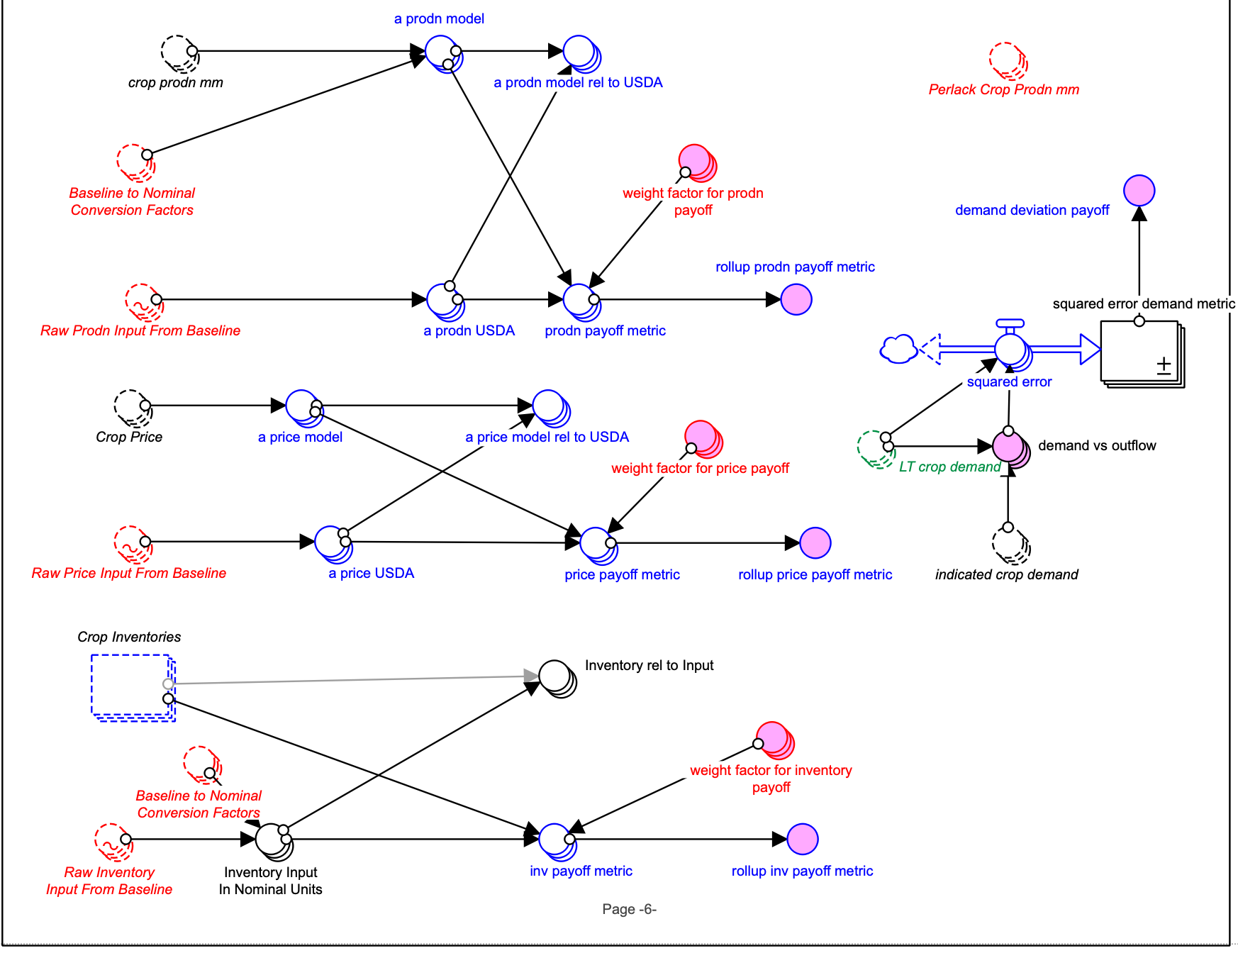

**II.6**

**II.5**

**II.4**

**II.3**

**II.2**

**II.1**

**I.3**

**I.2**

**I.1**

Question:

1. How we can modify Baseline to Nominal Conversion Factors? Units: USDA to nominal

(Maybe GCAM to nominal or something?)

**Module: Cellulosic to Ethanol**

Plant Financial and Operational and Scale factors and Logit input

1. BECCS FCI   
   Units: USD

Dimension: CtoATech,

1. BECCS FCI scale factor (Use the same scale factor as FCI scale factor or a new one?)

Units: unitless

Dimension: CtoATech

1. Next Plant BECCS FCI (either sum with NextPlant Expected FCI or separate converter?)

Units: USD

Dimension: CtoATEch, region

1. Expected BECCS Op Cost

Units: USD per Year

Dimension: CtoATech

1. BECCS Op Cost Scale factor (incorporate into scale factor used for fixed and expected other op cost or create another converter)

Units: unitless

Dimension: CtoATech

1. Next Plant Expected BECCS Op Cost (sum it with NextPlant Expected Other VBL Op cost or separate converter?)

Units: unitless

Dimension: CtoATech, region

1. Exp Other BECCS Sales Rev

Units: USD per Year

Dimension: CtoATech

1. BECCS Revenue scale (use existing one scaling factor or a new one)
2. Next Plant BECCS Sales Rev (separate or it is included in NextPlant other Coproduct sales rev?)

Units: USD per Year

Dimension: CtoATech, region

1. NextPlant ORNOVOC (other revenue (coproduct, BECCS, power) net of variable operating cost)- add Next Plant BECCS Sales Rev

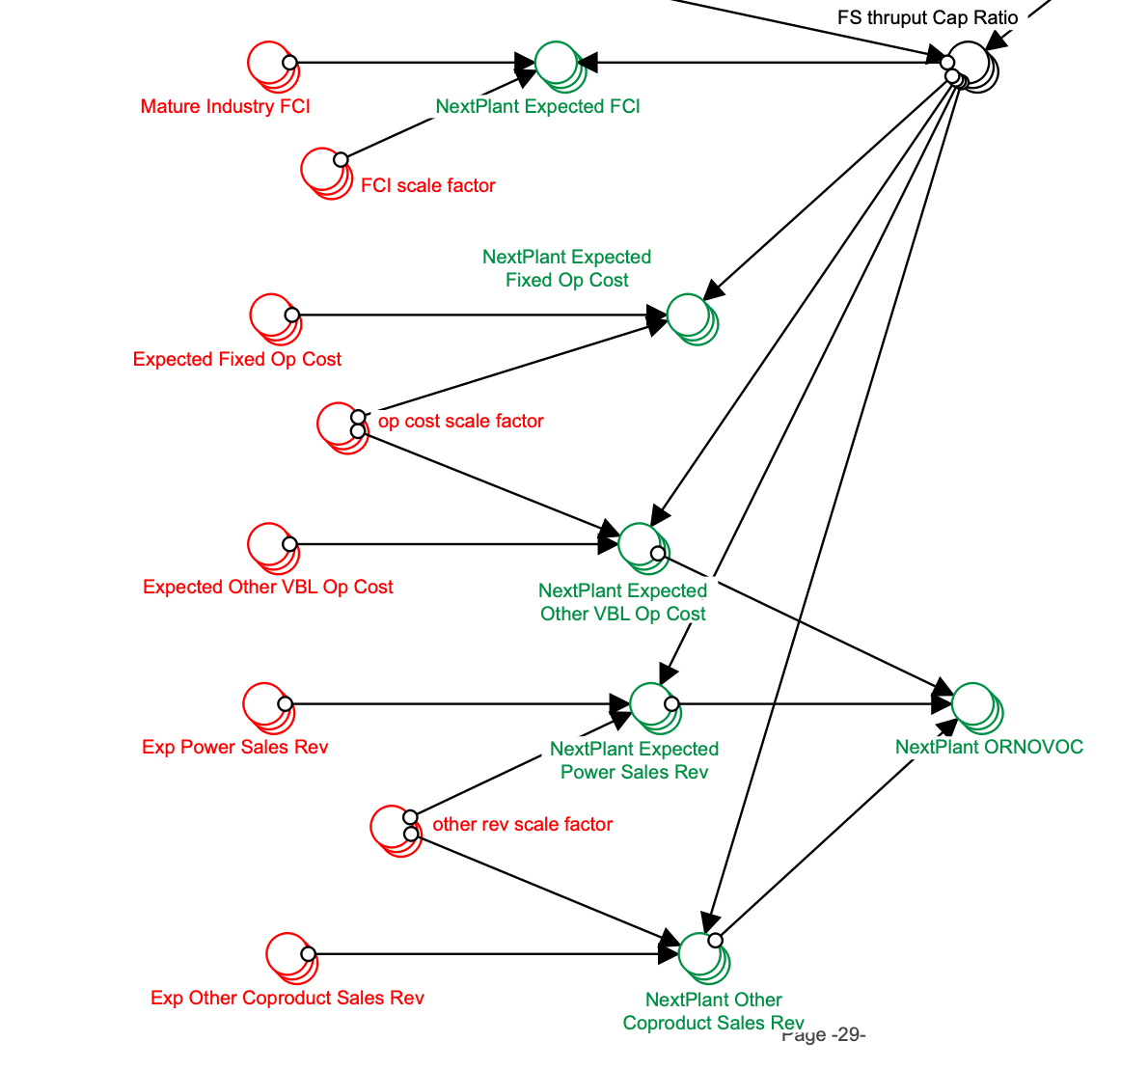

1. Next Plant Expected BECCS Op Cost (sum it with NextPlant Expected Other VBL Op cost or separate converter?)

Units: unitless

Dimension: CtoATech, region

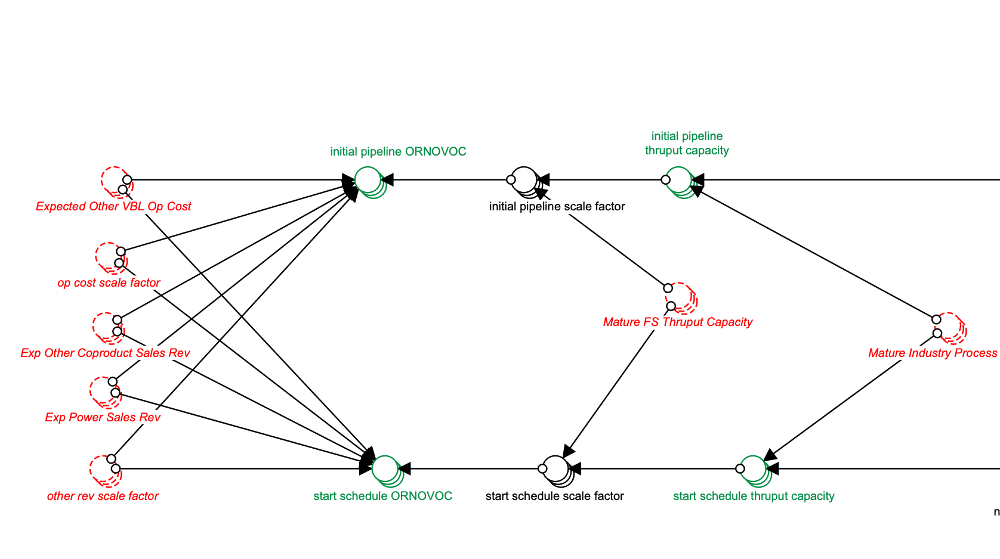

1. Next Plant BECCS Sales Rev (separate or it is included in NextPlant other Coproduct sales rev?)

Units: USD per Year

Dimension: CtoATech, region

1. Revenue scale factor for BECCS- use the same as here or not?

**MFSP and Utilization**

1. Next Plant BECCS Sales Rev (if it is nor in coproduct)

Units: USD per Year

Dimension: CtoATech, region

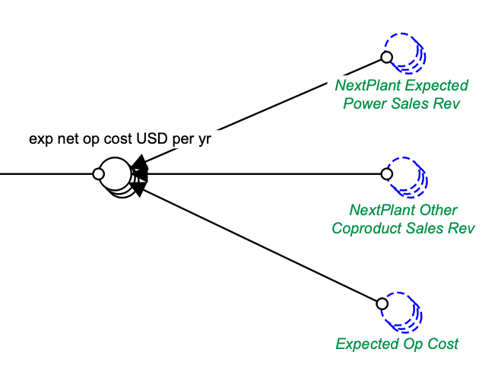

**Pro Forma Financials and NPV and Attractiveness**

1. Next Plant Expected BECCS Op Cost

Units: unitless

Dimension: CtoATech, region

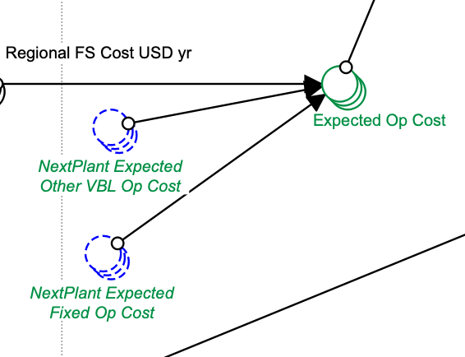

1. Next Plant BECCS Sales Rev

Units: USD per Year

Dimension: CtoATech, region

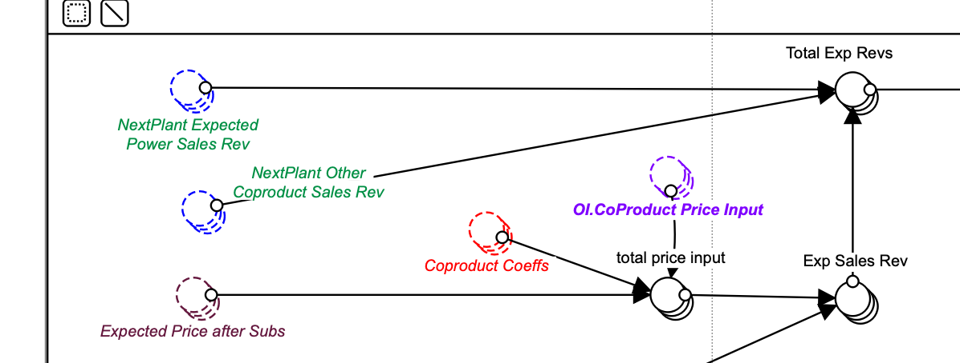

1. Next Plant BECCS FCI

Units: USD

Dimension: CtoATech, region

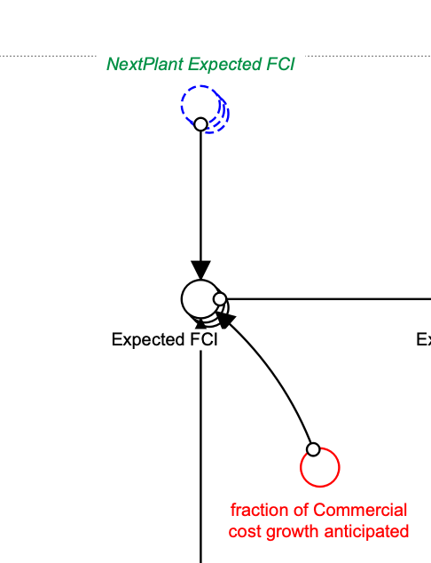

**GOVT POLICIES LOGIC**

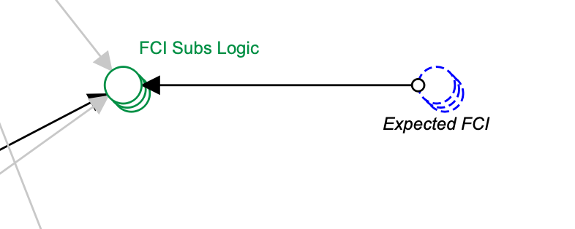

1. We can add expected BECCS FCI?

Units: USD

Dimension: CtoAtech, region

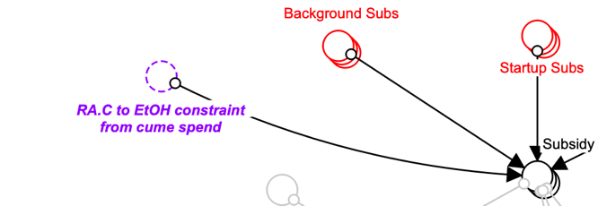

1. Maybe add BECCS subs here if there is any?

Units: unitless

Dimension: ConversionPolicy

**Module: Cellulosic to Hydrocarbon**

**Plant Financial and Operational and Scale factors and Logit input**

BECCS

1. BECCS FCI   
   Units: USD

Dimension: CtoRRTech,

1. BECCS FCI scale factor (Use the same scale factor as FCI scale factor or a new one?)

Units: unitless

Dimension: CtoRRTech

1. Next Plant BECCS FCI (either sum with NextPlant Expected FCI or separate converter?)

Units: USD

Dimension: CtoRRTEch, region

1. Expected BECCS Op Cost

Units: USD per Year

Dimension: CtoRRTech

1. BECCS Op Cost Scale factor (incorporate into scale factor used for fixed and expected other op cost or create another converter)

Units: unitless

Dimension: CtoRRTech

1. Next Plant Expected BECCS Op Cost(sum it with NextPlant Expected Other VBL Op cost or separate converter?)

Units: unitless

Dimension: CtoRRTech, region

1. Exp Other BECCS Sales Rev

Units: USD per Year

Dimension: CtoRRTech

1. BECCS Revenue scale (use existing one scaling factor or a new one)
2. Next Plant BECCS Sales Rev (separate or it is included in NextPlant other Coproduct sales rev?)

Units: USD per Year

Dimension: CtoRRTech, region

1. NextPlant ORNOVOC (other revenue (coproduct, BECCS, power) net of variable operating cost)- add Next Plant BECCS Sales Rev

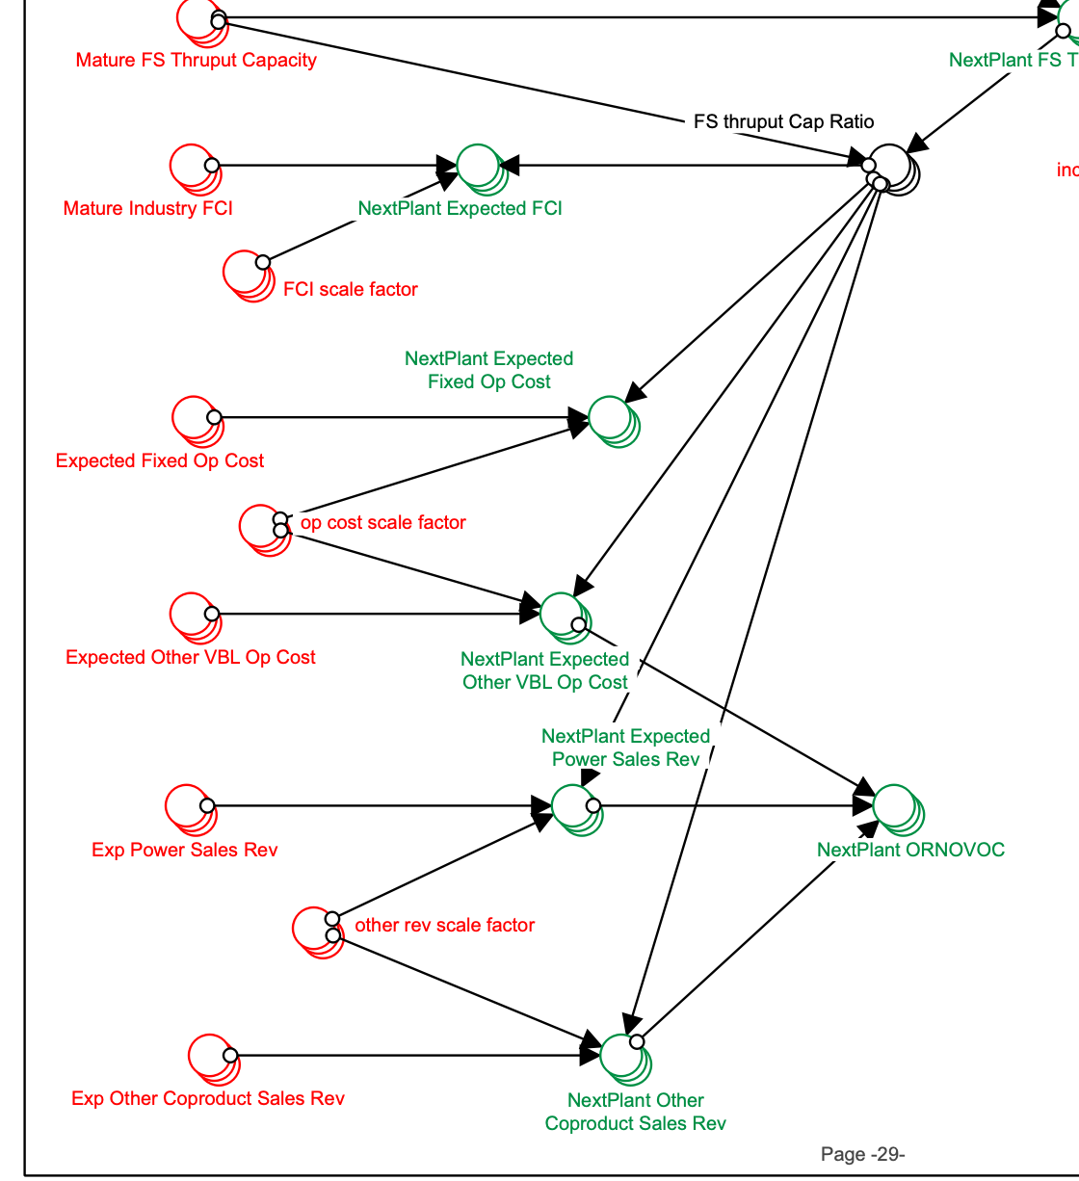

Do we need to include BECCS maturity in NextPlant FS Thruput Cap calculations?

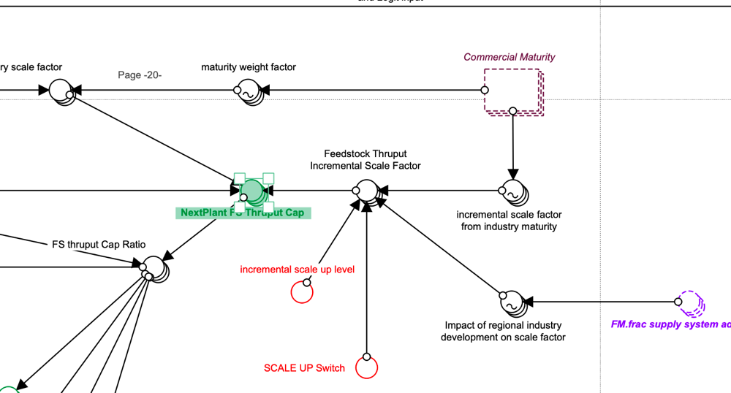

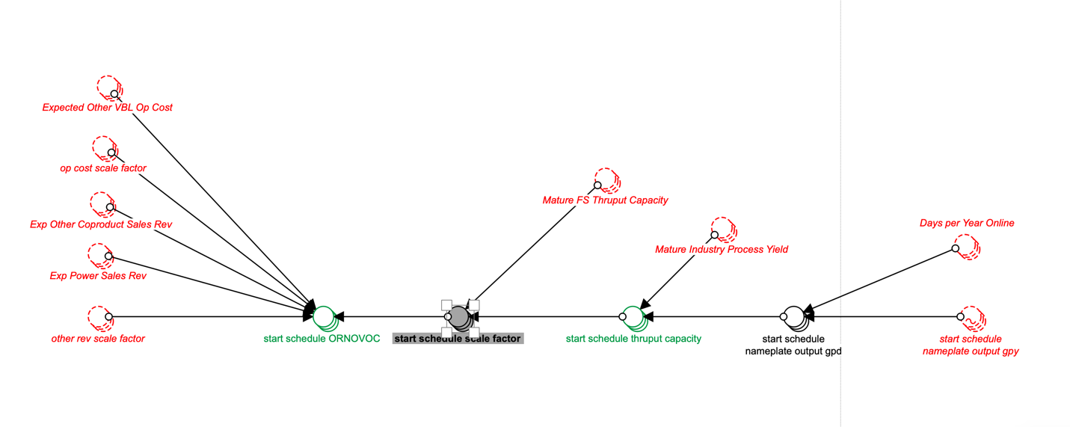

1. Expected BECCS Op Cost

Units: USD per Year

Dimension: CtoRRTech

1. BECCS Op Cost Scale factor (incorporate into scale factor used for fixed and expected other op cost or create another converter)

Units: unitless

Dimension: CtoRRTech

1. Next Plant BECCS Sales Rev (separate or it is included in NextPlant other Coproduct sales rev?)

Units: USD per Year

Dimension: CtoRRTech, region

1. Are we going to use other rev scale factor for BECCS rev?

**MFSP and Utilization**

1. Next Plant BECCS Sales Rev

Units: USD per Year

Dimension: CtoRRTech, region

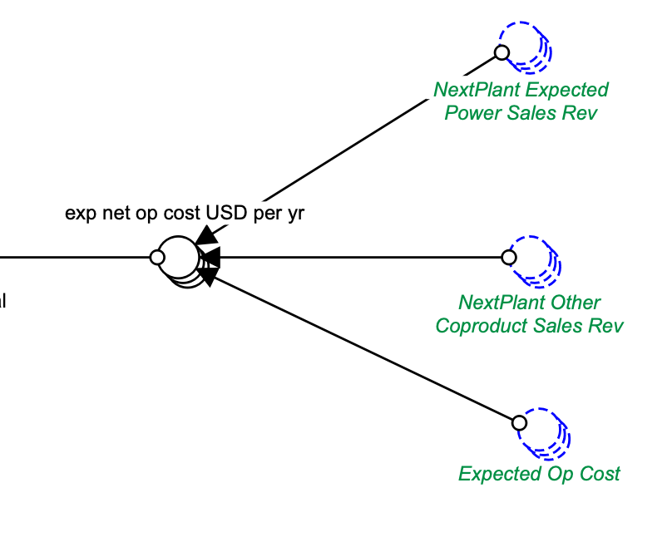

**Cumulative Govt Spend**

Is there any governmental sub if we implement BECCS?

**GOVT POLICIES LOGIC**

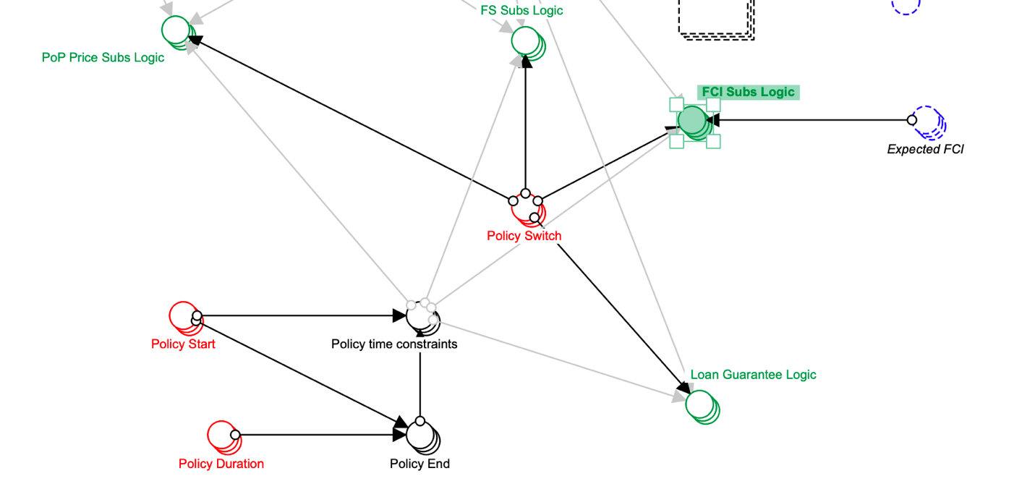

1. We can add expected BECCS FCI?

Units: USD

Dimension: CtoRRtech, region

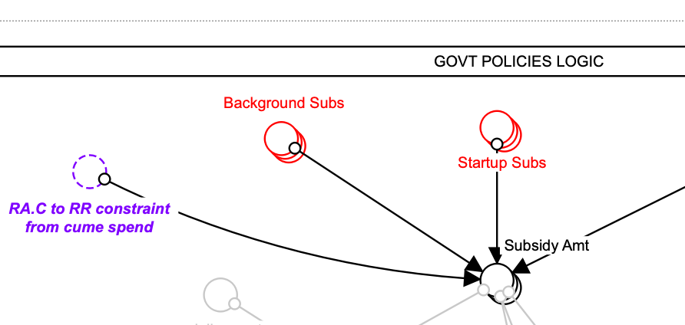

1. Maybe add BECCS subs here if there is any?

Units: unitless

Dimension: ConversionPolicy

﻿**Pro Forma Financials and NPV and Attractiveness** 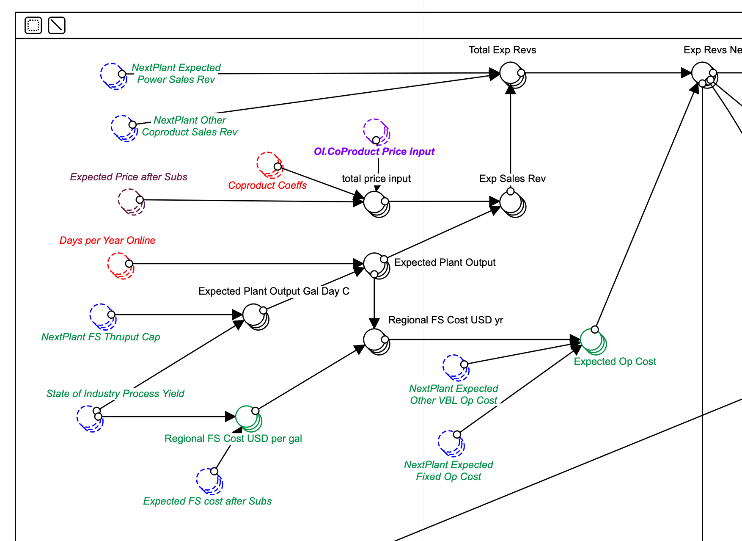

1. Next Plant BECCS Sales Rev

Units: USD per Year

Dimension: CtoRRTech, region

1. Next Plant Expected BECCS Op Cost

Units: unitless

Dimension: CtoRRTech, region

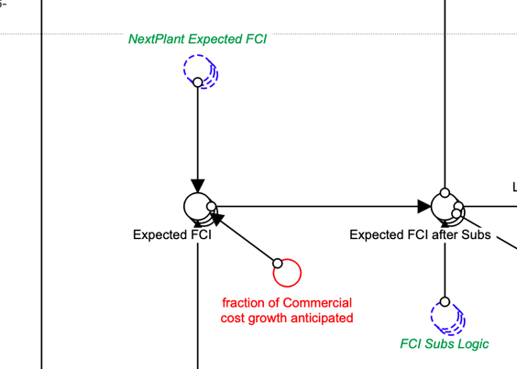

1. Next Plant BECCS FCI

Units: USD

Dimension: CtoRRTEch, region

﻿

Additional Question?

1. What do we know about BECCS maturity? (**Industry Development and Utilization and Learning Curves**)
2. Do we want to consider a separate loan for BECCS? (for example, for existing converting facilities. If yes, we would need to implement loan guarantee/ payment logic just for BECCS).

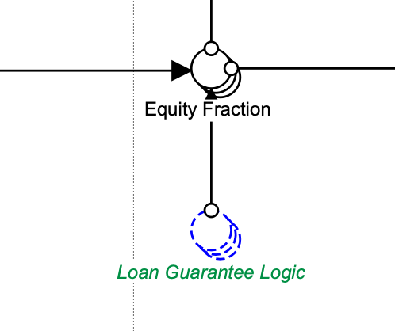

Screenshot from Pro Forma Financials and NPV and Attractiveness in CHC module

**Coal and gas CCS data**

From [Annual Technology Baseline](https://atb.nrel.gov/electricity/2019/data.html)

Gas – Combined Cycle with carbon capture sequestration

Base year – 2017$

Net Capacity factor:

Gas-CC-CCS-AvgCF = 51%,

Gas-CC-CCS-ConstantCF=87%

**Capex** ($/kW)= construction financing cost($/kW)+ overnight capital cost($/kW)

Capex ($/kW):

Gas-CC-CCS-AvgCF = 2,292$,

Gas-CC-CCS-ConstantCF=2,292$

Construction financing cost ($/kW):

Gas-CC-CCS-AvgCF = 50$,

Gas-CC-CCS-ConstantCF=50$

Overnight capital cost($/kW):

Gas-CC-CCS-AvgCF = 2,242$,

Gas-CC-CCS-ConstantCF=2,242$

Weighted Average Cost of Capital (WACC) (Nominal) (%)

Gas-CC-CCS-AvgCF = 5.3%,

Gas-CC-CCS-ConstantCF=5.3%

**Opex**

Fixed Operation and Maintenance Expenses ($/kW-yr):

Gas-CC-CCS-AvgCF = 34$

Gas-CC-CCS- ConstantCF = 34$

Variable Operation and Maintenance Expenses ($/MWh):

Gas-CC-CCS-AvgCF = 7$

Gas-CC-CCS- ConstantCF = 7$

Coal-Carbon capture sequestration-30%

Base year – 2017$

Net Capacity factor:

Coal-CCS 30%-AvgCF = 54%,

Coal-CCS 30%-ConstantCF=85%

**Capex** ($/kW)= construction financing cost($/kW)+ overnight capital cost($/kW)

Capex ($/kW):

Coal-new-AvgCF=$4,036

Coal-new-ConstantCF=$4,036

Coal-CCS 30%-AvgCF = 5,633$, (difference 1597$)

Coal-CCS 30%-ConstantCF=5,633$

Construction financing cost ($/kW):

Coal- new-AvgCF = 325$,

Coal- new-ConstantCF=325$

Coal-CCS 30%-AvgCF = 453$, (difference 128$)

Coal-CCS 30%-ConstantCF=453$

Overnight capital cost($/kW):

Coal-new-AvgCF = 3,711$,

Coal-new-ConstantCF=3,711$

Coal-CCS 30%-AvgCF = 5,180$, (difference 1469$)

Coal-CCS 30%-ConstantCF=5,180$

Weighted Average Cost of Capital (WACC) (Nominal) (%)

Coal-CCS 30%-AvgCF = 5.3%,

Coal-CCS 30%-ConstantCF=5.3%

**Opex**

Fixed Operation and Maintenance Expenses ($/kW-yr):

Coal-new-AvgCF = 33$

Coal-new-ConstantCF = 33$

Coal-CCS 30%-AvgCF = 69$ (difference 36$)

Coal-CCS 30%-ConstantCF = 69$

Variable Operation and Maintenance Expenses ($/MWh):

Coal-new-AvgCF = 5$

Coal-new-ConstantCF = 5$

Coal-CCS 30%-AvgCF = 7$

Coal-CCS 30%-ConstantCF = 7$

Coal-Carbon capture sequestration-90%

Base year – 2017$

Net Capacity factor:

Coal-CCS 90%-AvgCF = 54%,

Coal-CCS 90%-ConstantCF=85%

**Capex** ($/kW)= construction financing cost($/kW)+ overnight capital cost($/kW)

Capex ($/kW):

Coal-new-AvgCF=$4,036

Coal-new-ConstantCF=$4,036

Coal-CCS 90%-AvgCF = 6,299$, (difference 2263)

Coal-CCS 90%-ConstantCF=6,299$

Construction financing cost ($/kW):

Coal- new-AvgCF = 325$,

Coal- new-ConstantCF=325$

Coal-CCS 90%-AvgCF = 501$, (difference 176$)

Coal-CCS 90%-ConstantCF=501$

Overnight capital cost($/kW):

Coal-new-AvgCF = 3,711$,

Coal-new-ConstantCF=3,711$

Coal-CCS 90%-AvgCF = 5,728$, (difference 2017$)

Coal-CCS 90%-ConstantCF=5,728$

Weighted Average Cost of Capital (WACC) (Nominal) (%)

Coal-CCS 90%-AvgCF = 5.3%,

Coal-CCS 90%-ConstantCF=5.3%

**Opex**

Fixed Operation and Maintenance Expenses ($/kW-yr):

Coal-new-AvgCF = 33$

Coal-new-ConstantCF = 33$

Coal-CCS 90%-AvgCF = 80$ (difference 47$)

Coal-CCS 90%-ConstantCF = 80$

Variable Operation and Maintenance Expenses ($/MWh):

Coal-new-AvgCF = 5$

Coal-new-ConstantCF = 5$

Coal-CCS 90%-AvgCF = 10$ (difference 5$)

Coal-CCS 90%-ConstantCF = 10$

Scaling factors can be adjusted from 2018 ReEDS documentation

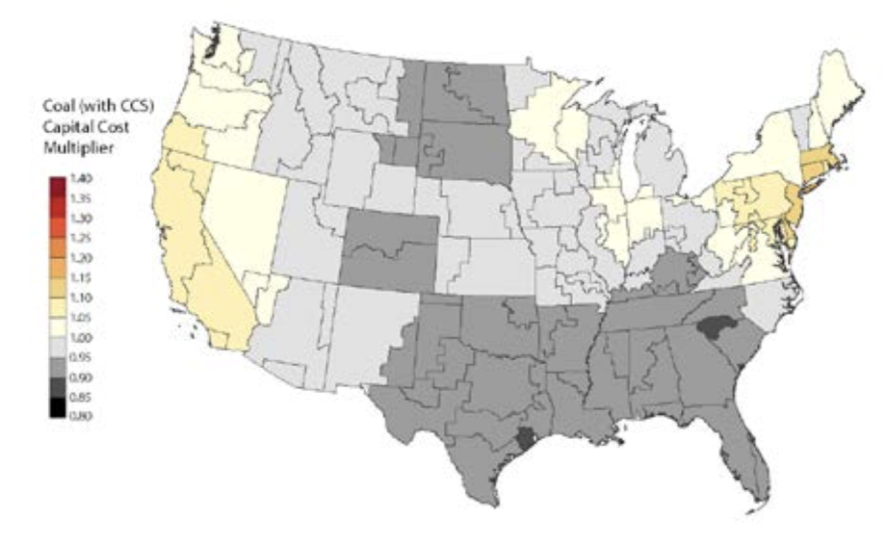

Geospatial analysis of near-term potential for carbon-negative bioenergy in the United States 1

Reasons:

1. Find suitable basins for CO2 injections
2. Transport of CO2 from facilities to CCS plant

Potential – 370 Mt CO2/ year by 2020 of negative emissions could be supplied

Reality – 100 Mt CO2/ year by 2020 due to:

- absence of long-distance biomass and CO2 transport

- storage and injection limitations

The most favorable places for widespread deployment of dedicated energy crops: Illinois basin, Gulf region, and western North Dakota

Conditions for BECCS deployment:

1. Biomass potential
2. Storage limitations (Injection rate capacity, a function of the porosity, permeability, and thickness of the porous storage basin, is the annual CO2 injection rate achievable in a single well in a storage site (18). Injection rates that exceed the injectivity of a particular storage reservoir increase subsurface pressures to unacceptably high levels and may create fractures in the cap rock, induce seismicity, or acti- vate faults, making the project more prone to leakage and costlier to monitor.)

Most attractive places for BECCS – large injection rate

1. Transportation:

* CO22

|  |  |  |  |
| --- | --- | --- | --- |
| Region | Capacity | Distance | Price |
| Midwest | 2–3 million tonnes per year | 10 km | US$ 0.15 per tonne of CO2 |
| 5 million tonnes of CO2 per year (800 MW coal-fired power plant with carbon capture) | 100 km | US$ 1.16 per tonne of CO2 |
| 2 million tonnes per year | 100 km | US$ 2.23 per tonne of CO2 |
| 200 km | US$ 4.06 per tonne CO2 |
| lower in the Central US | 5 million tonnes of CO2 per year | 100 km | US$ 0.39 per tonne of CO2 |
| the Northeast US | 5 million tonnes of CO2 per year | 100 km | US$ 0.2 per tonne of CO2 |

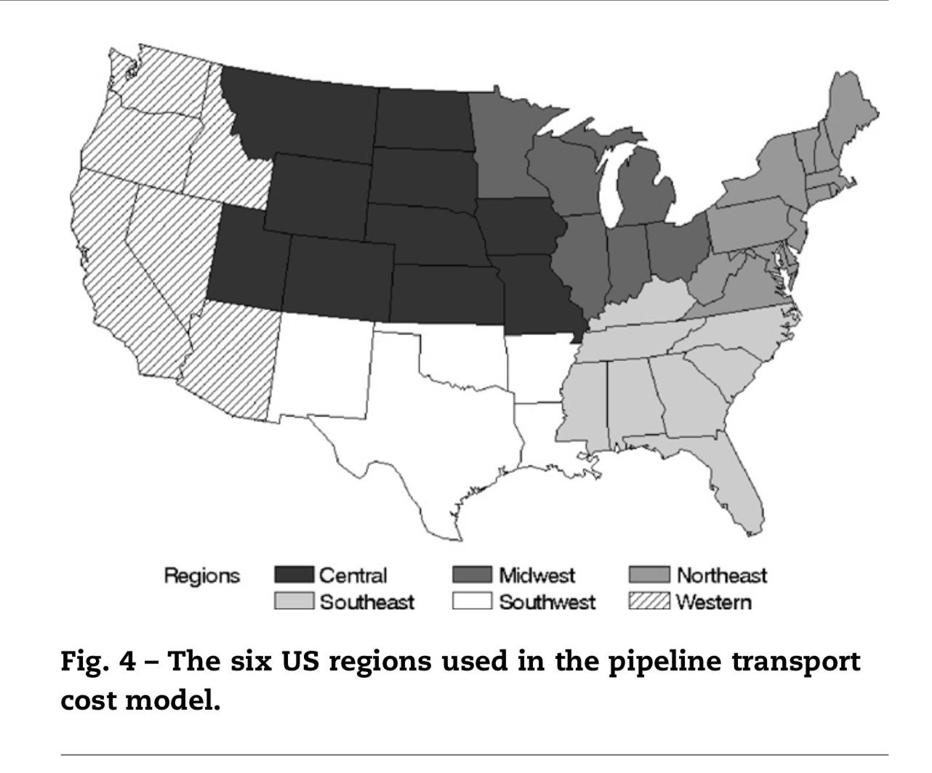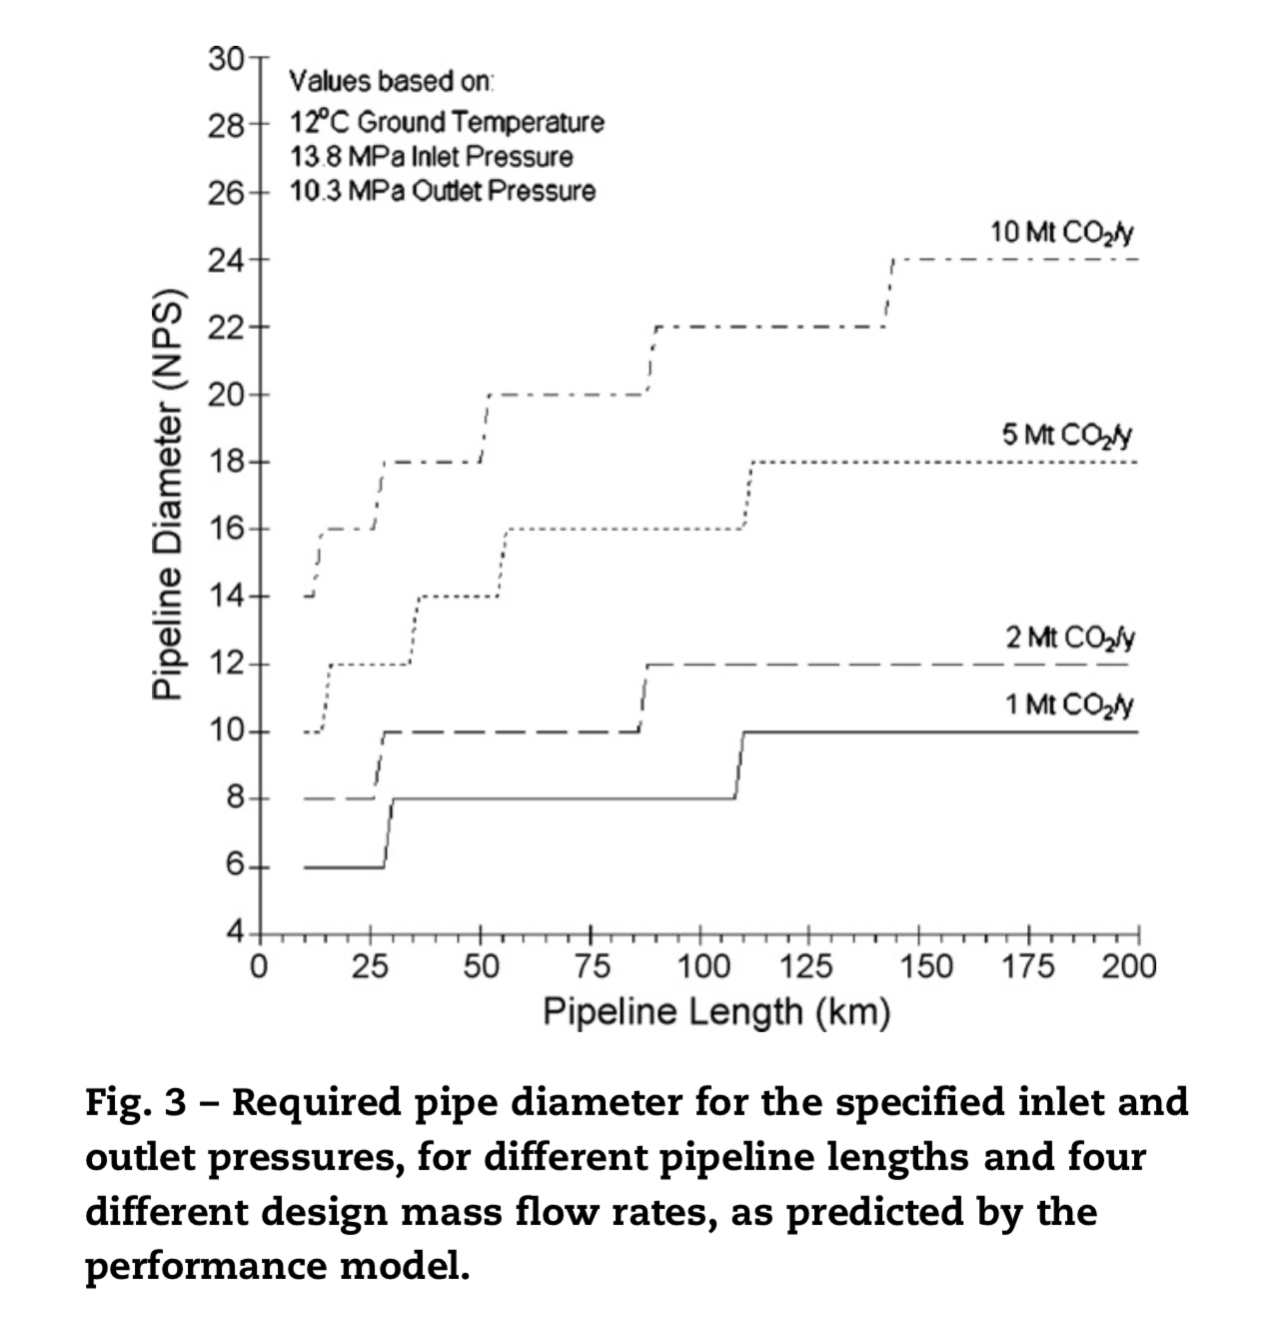

90 % probability that the cost per tonne of CO2 is between US$ 1.03 and US$ 2.63 per tonne of CO2 transported in the Midwest US

To reduce difficulties in design and operation, it is generally recommended that a CO2 pipeline operate at pressures greater than 8.6 MPa where the sharp changes in compressibility of CO2 can be avoided across a range of temperatures that may be encountered in the pipeline system.

the density of CO2 varies between approximately 800 and 1000 kg/m3

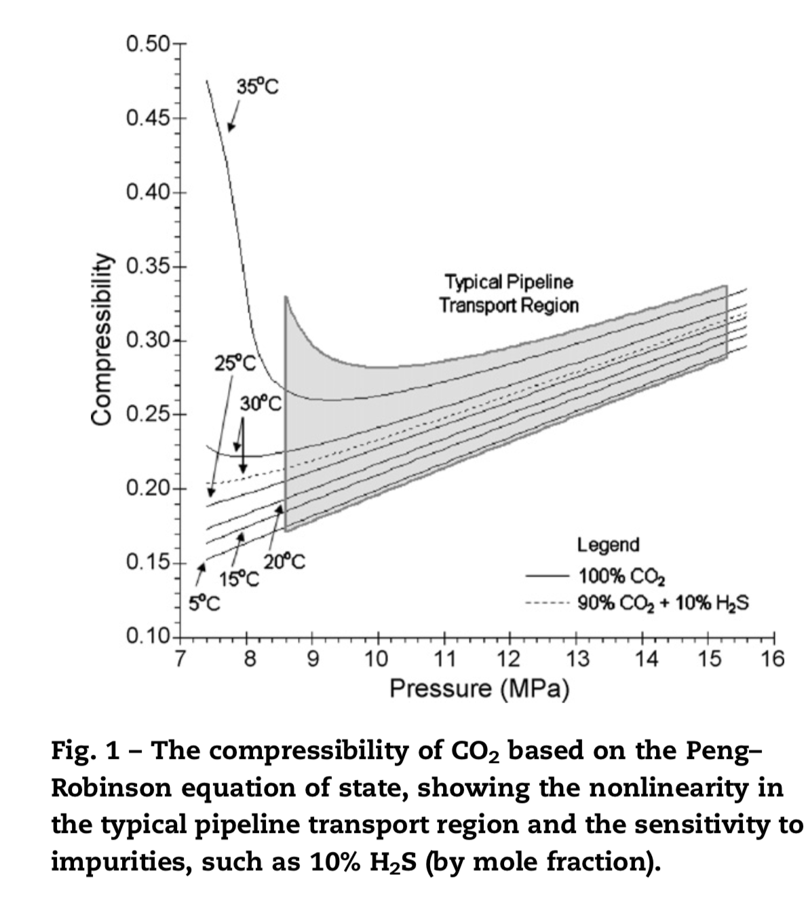

Price of CO2 transport is based on natural gas due to:

1. similar pressures, approximately 10 MPa and greater
2. Assuming the CO2 is dry, which is a common requirement for CCS, both pipelines will require similar materials

Regions used here are the same as those used by the Energy Information Administration (2006) for natural gas pipeline regions

the O&M cost of operating 1 km on annual basis - US$ 3250 per kilometer of pipeline in 2004 dollars

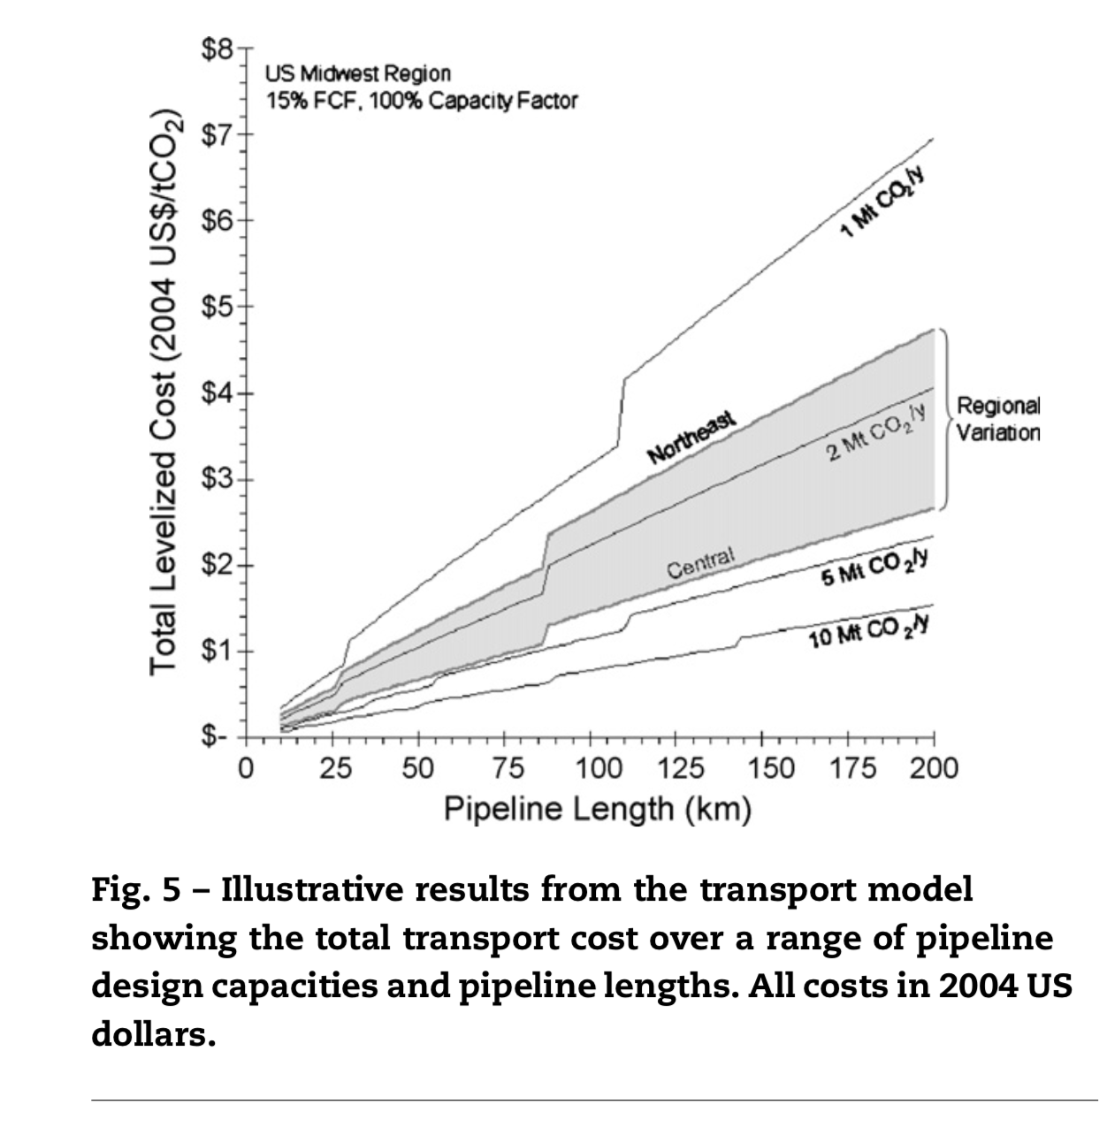

* biomass - more expensive to transport than fossil. Woody bio which is the highest energy content is too expansive to transport for more than 50 miles; other lignocellulosic () – 12 miles

2020

220-230 Mt of lignocellulosic biomass will be available annually :

– 370-400 Mt CO2/ year for sequestration

– 0.1 Mt biomass per county per year

– 50% - agricul residue, 40% - woody biomass, 10% - energy crop

* 37% of biomass in 2020 – corn belt

Overlap of sequestration and biomass production region

* Storage potential – 44% of the counties
* Storage potential counties produce 31-32% (110-120 Mt CO2/year) of total biomass potential in 2020 where 41% - agricult residues, 44% - woody, 16% - energy crop

2040

– 610-1040 Mt / year for sequestration

* Energy crops – 61-75% (what are our results?)
* CO2- 1040-1780 Mt CO2/year – only 38% is collocated with storage (400-680 MtCO2/year)

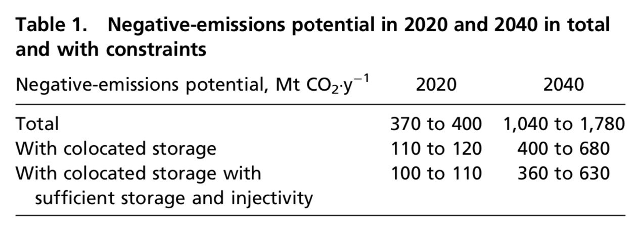

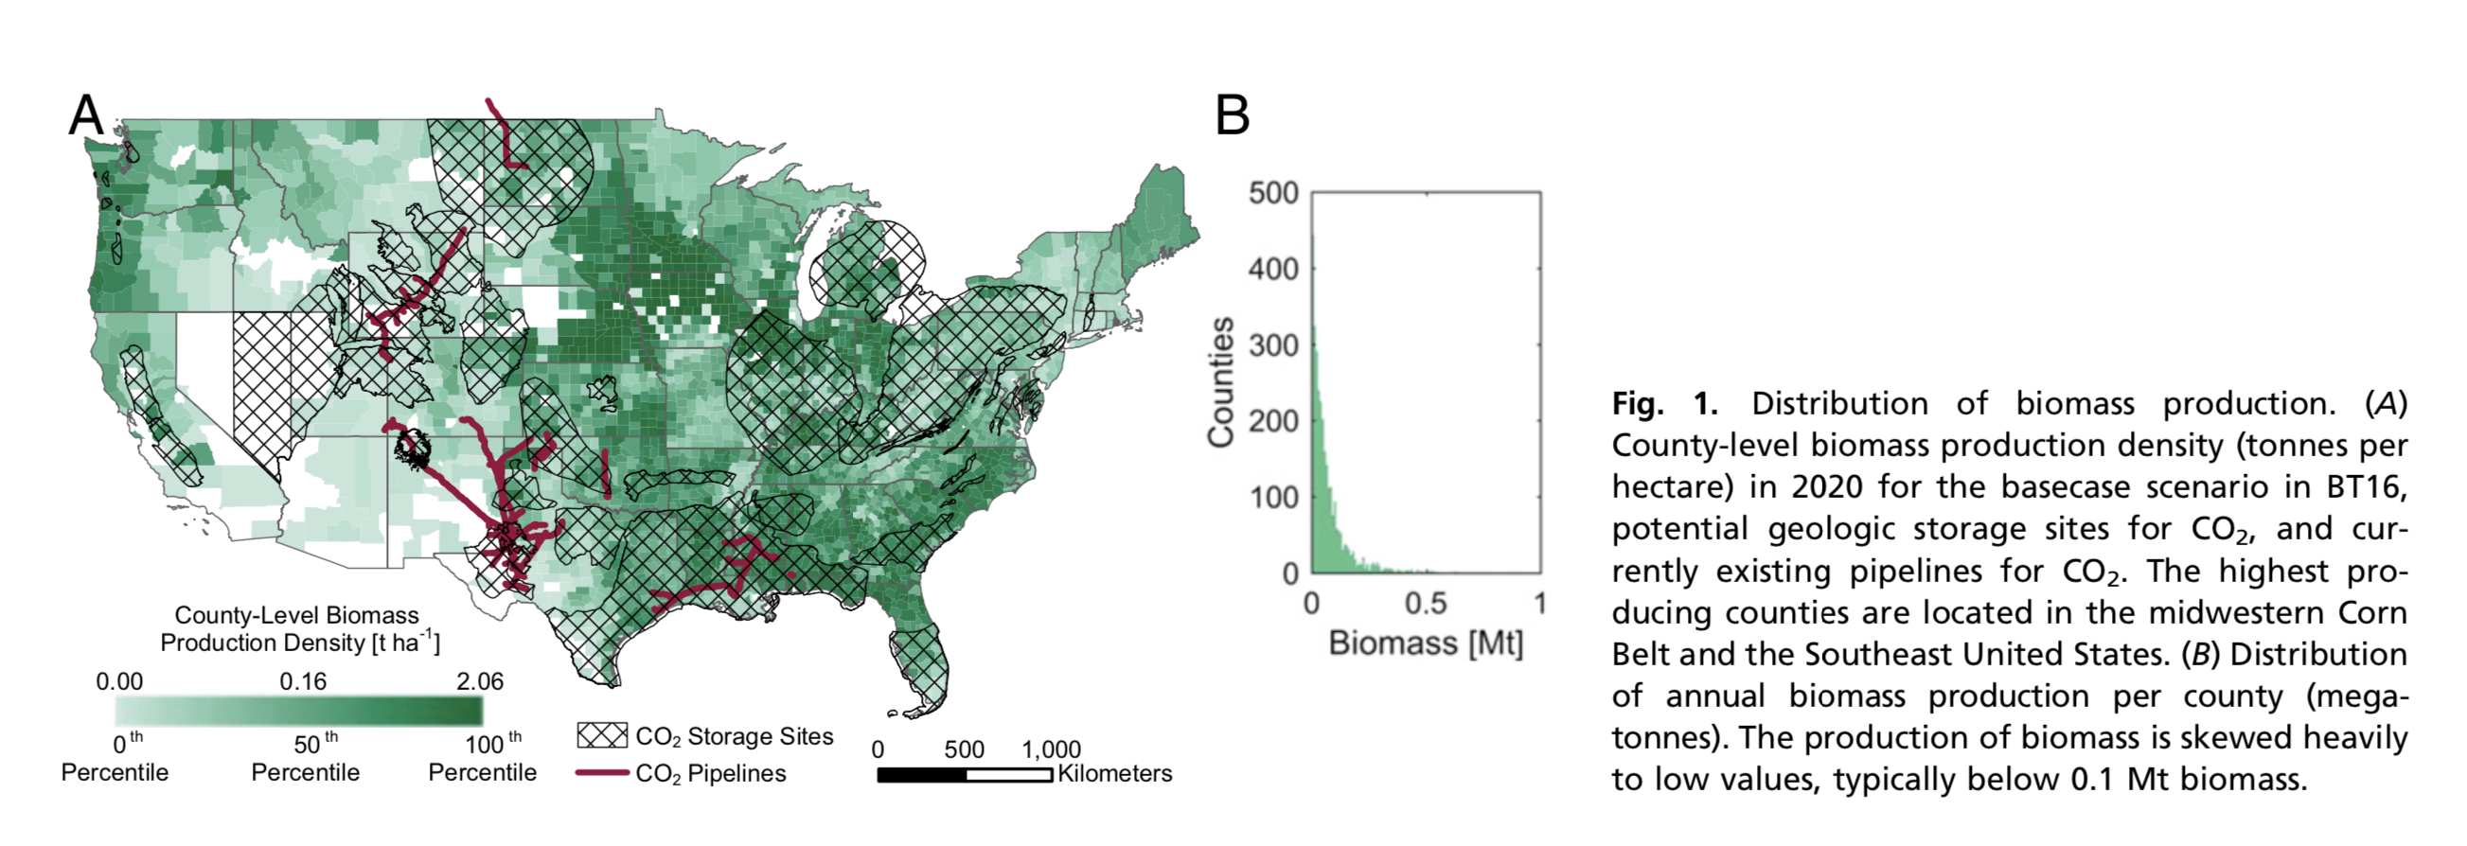

Potential storage (by USGS):

* sedimentary formations of siliciclastic and carbonate rocks that exist in forms of saline aquifers or oil and gas reservoirs that have sufficient porosity and permeability to store CO2.
* adequate depth for CO2 injection (>900 m) and pres ence of a seal formation to trap the injected CO2 (28).

Injection per well: 0.001 Mt Co2/year – 60 mT CO2/ year;

13 counties in the US produce more biomass than it is possible to inject

The highest injection rate -Gulf - 5 Mt CO2/ year

The lowest injection rate – Nevada, Utah, Colorado – 0.025Mt CO2/ year

Commercial plant – from 1 Mt CO2/ year

Demonstration plant – 0.01-0.3 Mt CO2/ year (below 0.25 is not feasible)

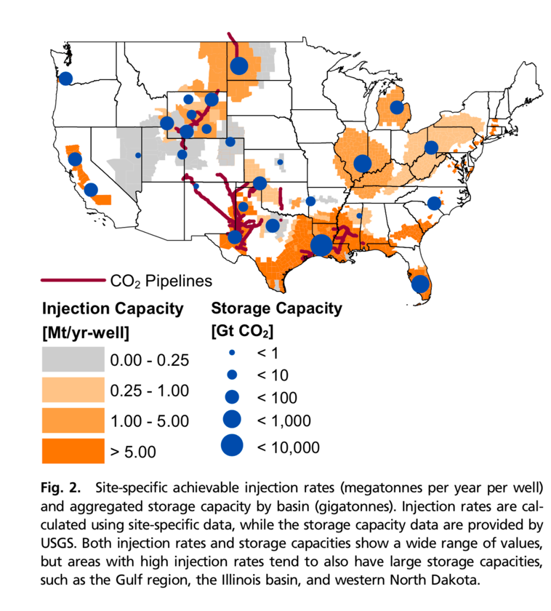

Total CO2 from 2020 till 2100 assuming 100% sequestration - 75 Gt to 121 Gt CO2

Total basins – 26: 15 basins – fill less than 5%; 9 – less than 40% of capacity; Kansas basin and black mirror basin (considering of site seq) – 100% fill

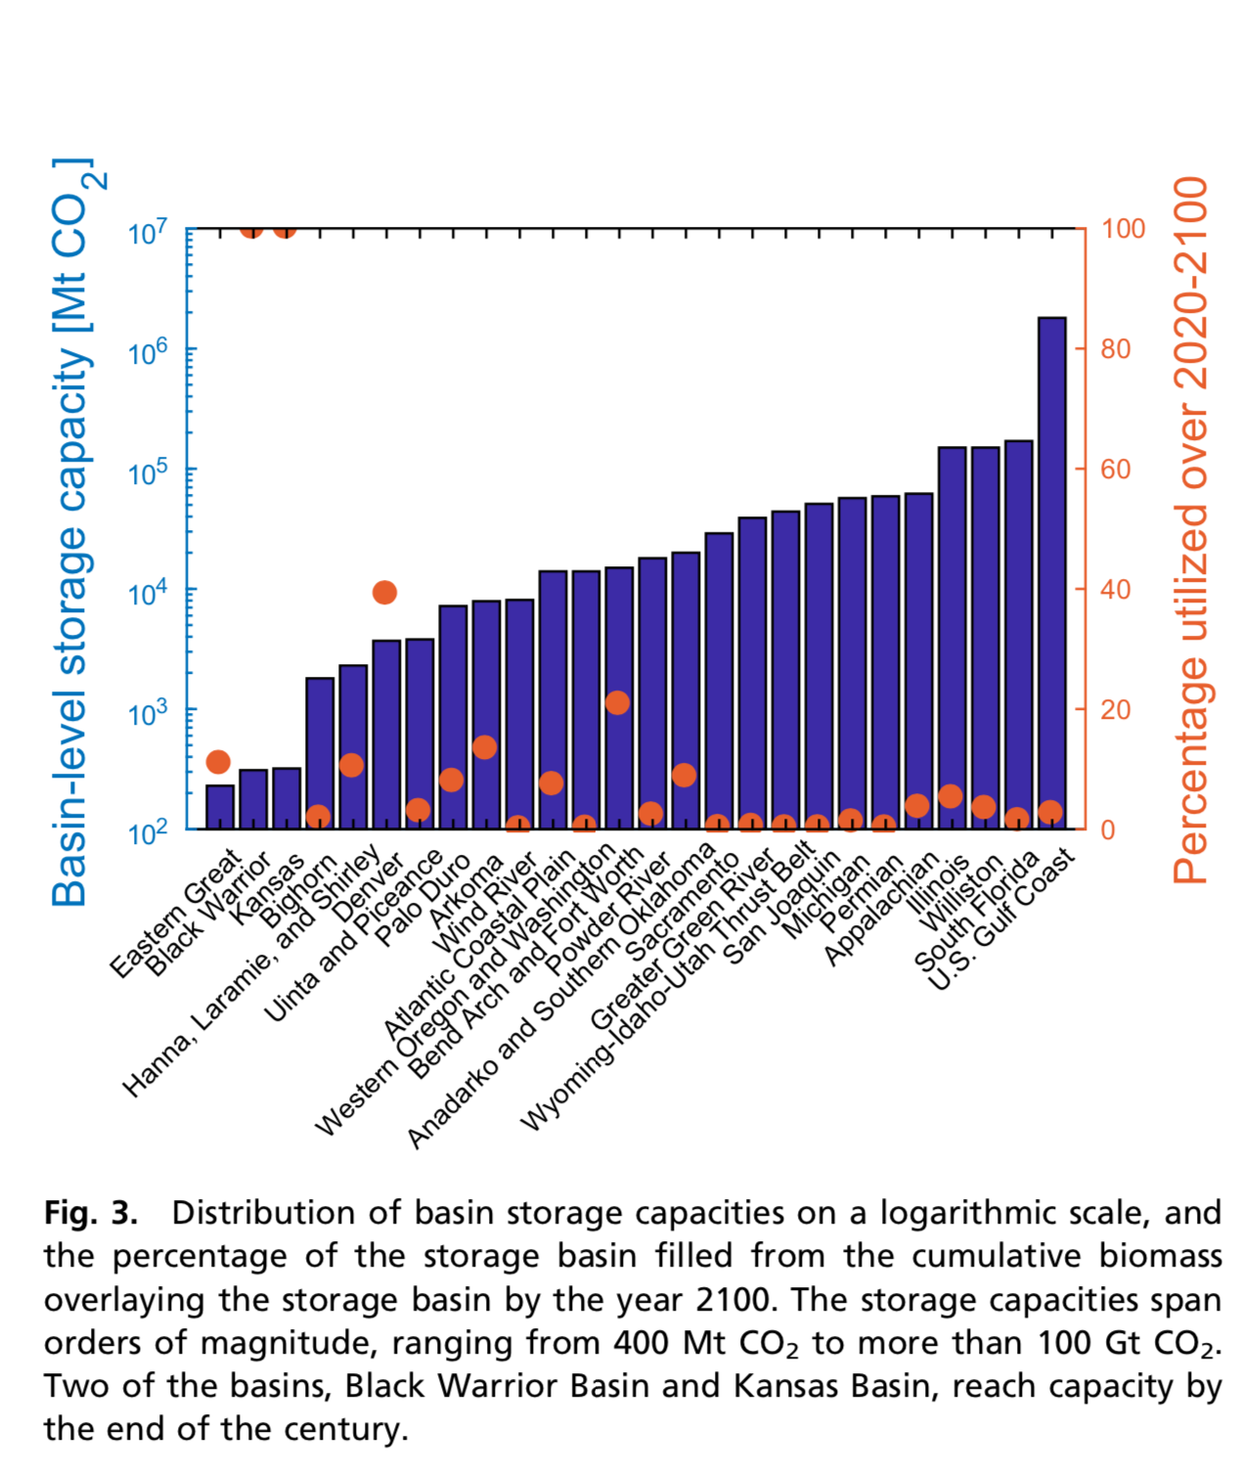

The most promising areas for nearest BECCS deployment – Illinois, ND, Gulf

Pros of Gulf: existing infrastructure; explored area; existing oil and gas CCS;

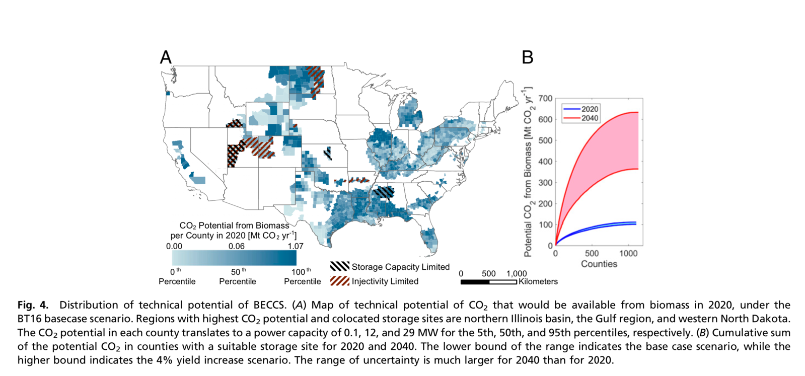

Carbon Capture and Sequestration – EIA

**Electricity Market Module**

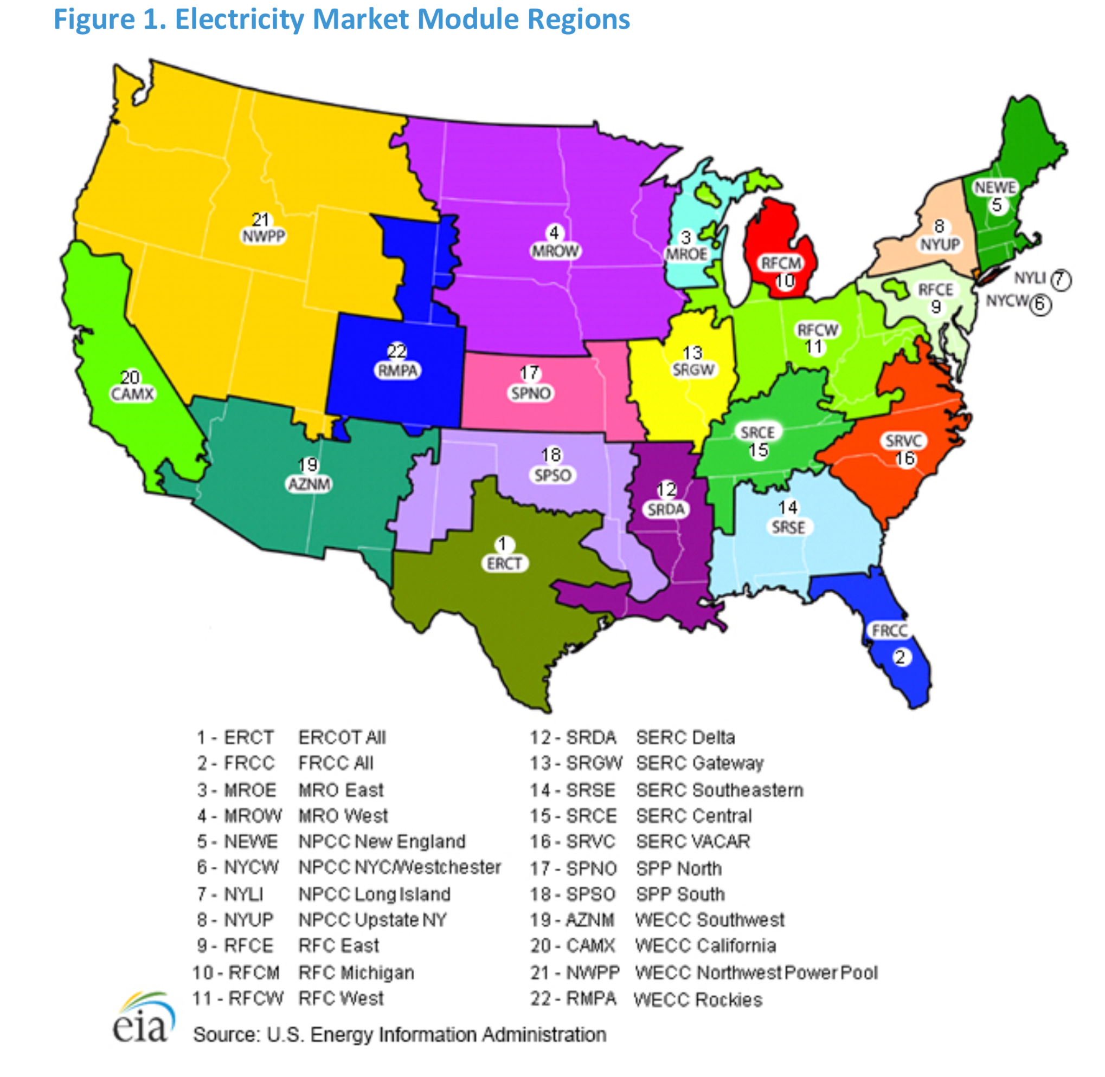

Generating Capacity Types

USC with 30% carbon capture and sequestration (CCS)

USC with 90% CCS

Advanced combined cycle with CCS

Biomass—fluidized bed

AEO2019 assumes new coal plants without CCS cannot be built because of emission standards for new plants. These technologies exist in the modeling framework, but they are not assumed to be available to be built in the projections.

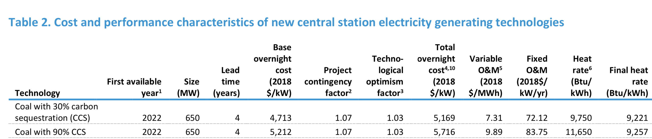



3 The technological optimism factor is applied to the first four units of a new, unproven design; it reflects the demonstrated tendency to underestimate actual costs for a first-of-a-kind unit.

The technological optimism factor represents the demonstrated tendency to underestimate actual costs for a first-of-a-kind, unproven technology. As experience is gained, after building four units, the technological optimism factor is gradually reduced to 1.0

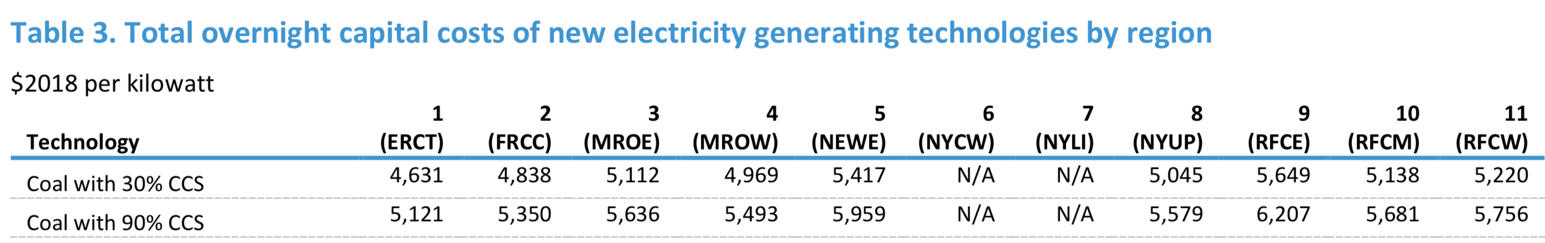











In the AEO2019, the assumed debt fraction for new builds is 60%, with a corresponding 40% equity fraction.

Although only coal-fired technologies with CCS are assumed available for new builds, the technology that captures 30% of CO2 emissions is still considered a high emitter relative to other new sources and may continue to face potential financial risk if carbon emission controls are further strengthened. Only the technology designed to capture 90% of CO2 emissions does not receive the three-percentage-point increase in cost of capital.



The weights are based on the share of the initial cost estimate that is attributable to each component (Table 5)

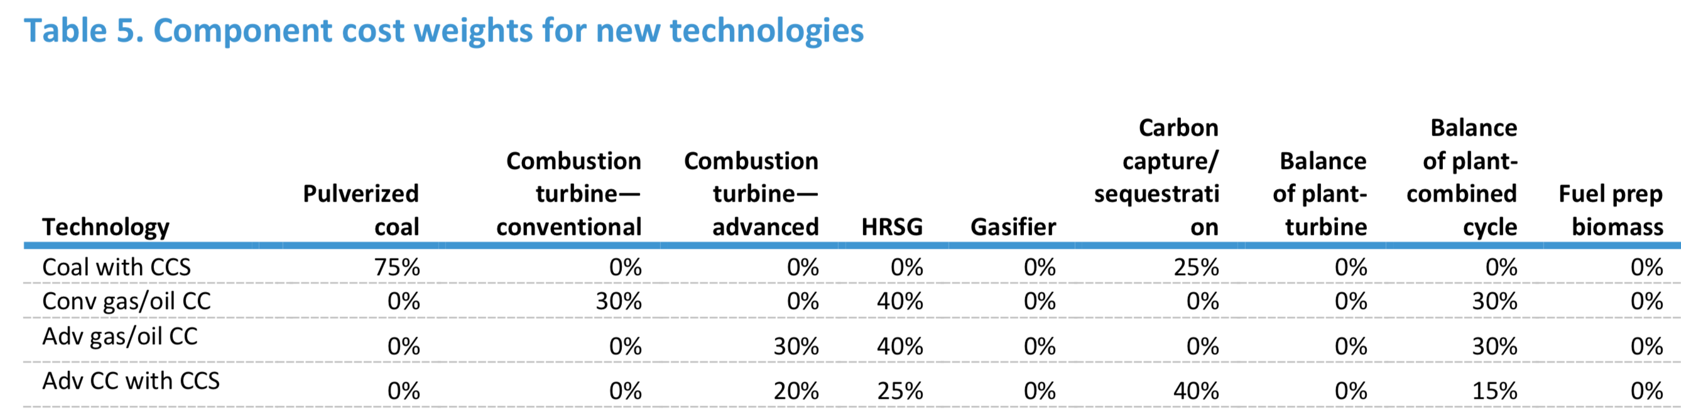

The Clean Power Plan (CPP) is not included in any AEO2019 cases.

***Carbon capture and sequestration retrofits***

The EMM includes the option of retrofitting existing coal plants for CCS. The modeling structure for CCS retrofits within the EMM was developed by the National Energy Technology Laboratory [16] and uses a generic model of retrofit costs as a function of basic plant characteristics (such as heat rate). The costs have been adjusted to be consistent with costs of new CCS technologies. The CCS retrofits are assumed to remove 90% of the carbon input. The addition of the CCS equipment results in a capacity derate of about 30% and a reduced efficiency of 43% at the existing coal plant. The costs depend on the size and efficiency of the plant, with the capital costs averaging $1,762 per kW and ranging from $1,284 per kW to $2,474 per kW. This analysis assumes that only plants greater than 500 MW and with heat rates lower than 12,000 Btu per kilowatthour (kWh) would be considered for CCS retrofits.

Beginning in AEO2018, the EMM includes the option to retrofit existing natural gas-fired combined-cycle plants with CCS technology, also based on the modeling structure developed by NETL.

**Levelized Cost and Levelized Avoided Cost of New Generation Resources in the *Annual Energy Outlook 2019***

Key inputs to calculating LCOE include capital costs, fuel costs, fixed and variable operations and maintenance (O&M) costs, financing costs, and an assumed utilization rate for each plant type.5

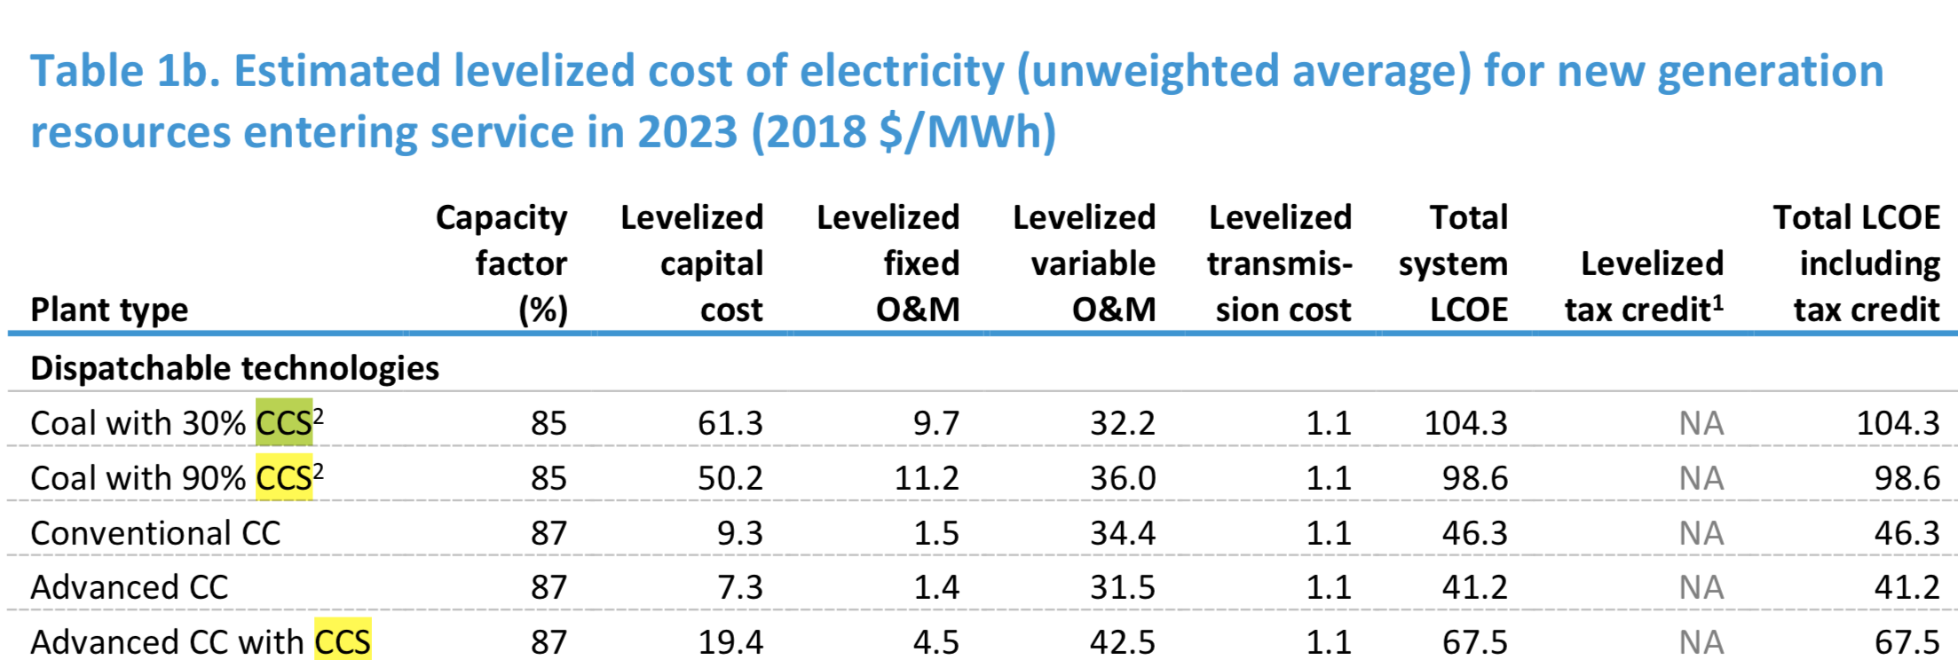

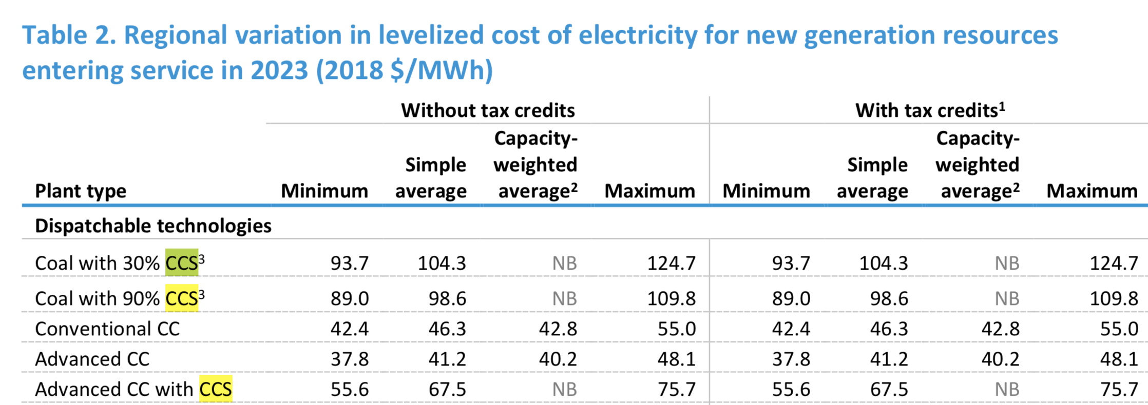

2The capacity-weighted average is the avg level cost per technology , weighted by the new capacity coming onlin in   
each region. The capacity additions for each region are based on additions from 2021–2023. Technologies for which capacity additions are not expected do not have a capacity-weighted average and are marked as *NB* or not built.

Table 3 provides the range of LACE estimates for different capacity types. EIA calculated the LACE in this table assuming the same maximum capacity factor as used for the LCOE. Values are not shown for combustion turbines because combustion turbines are generally built for their capacity value to meet a reserve margin rather than for generation requirements and to collect avoided energy costs.

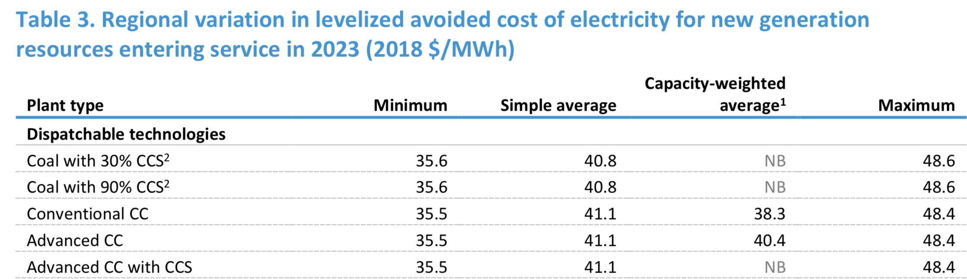

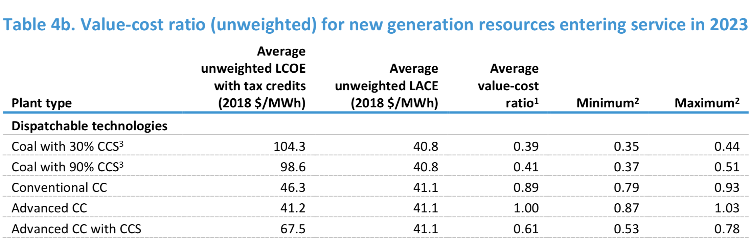

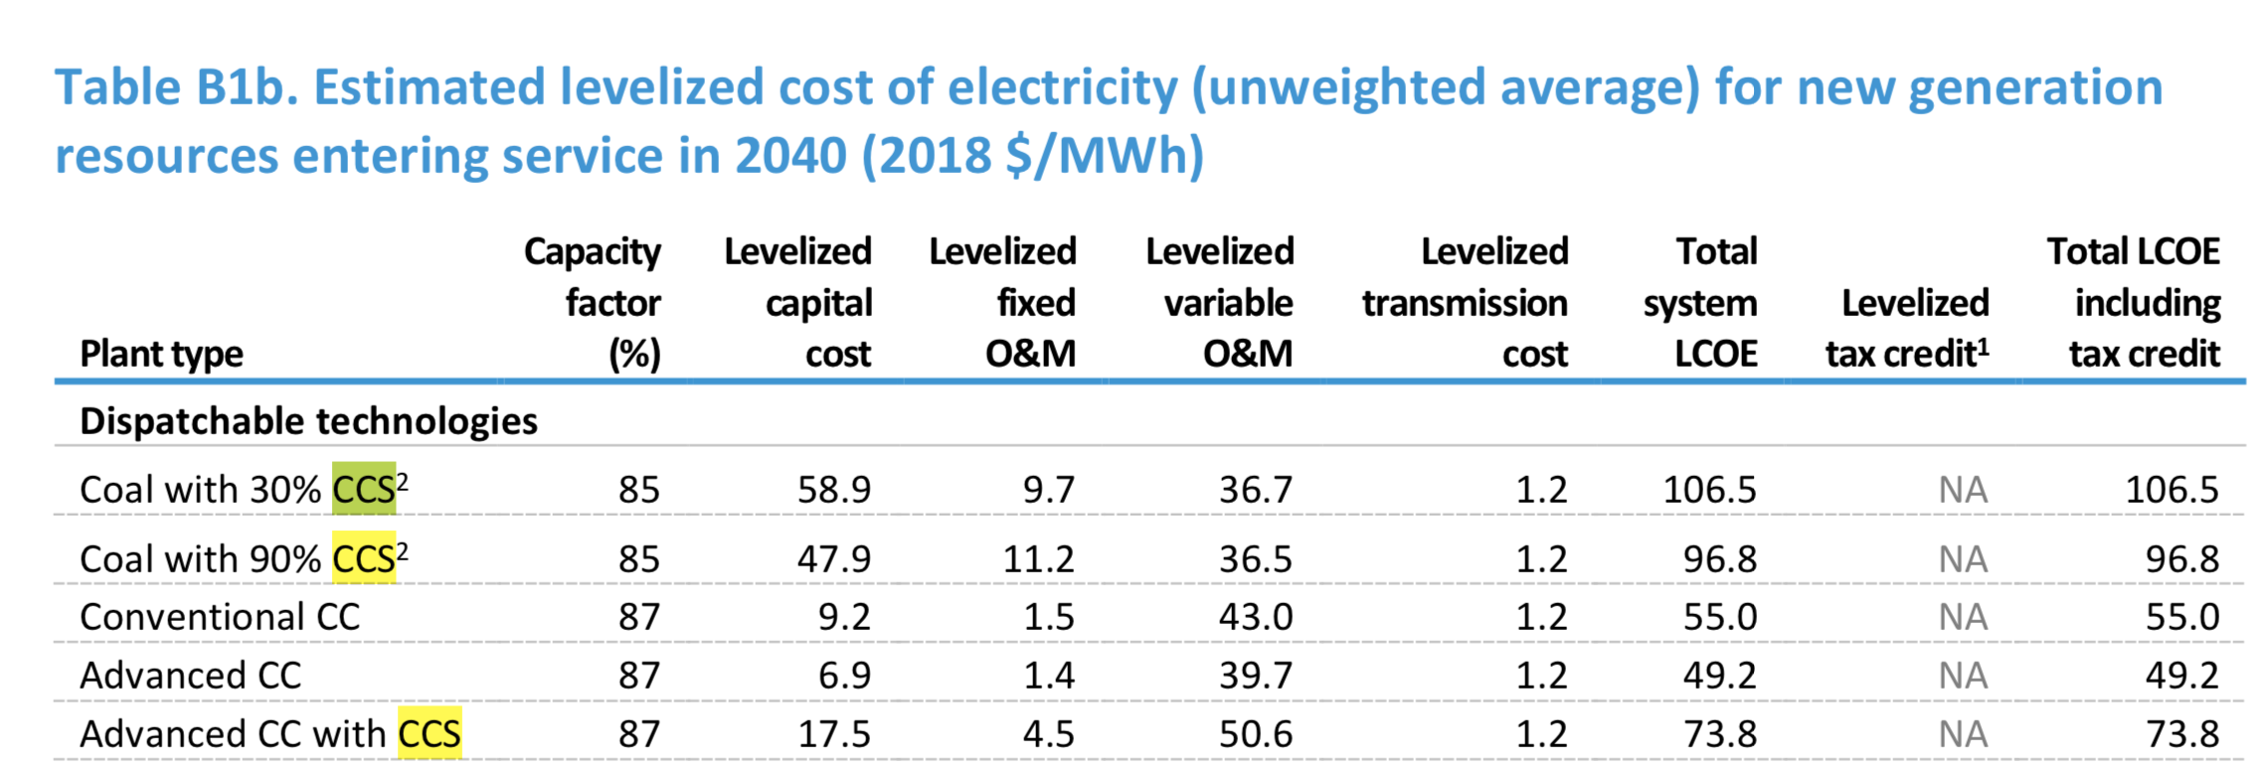

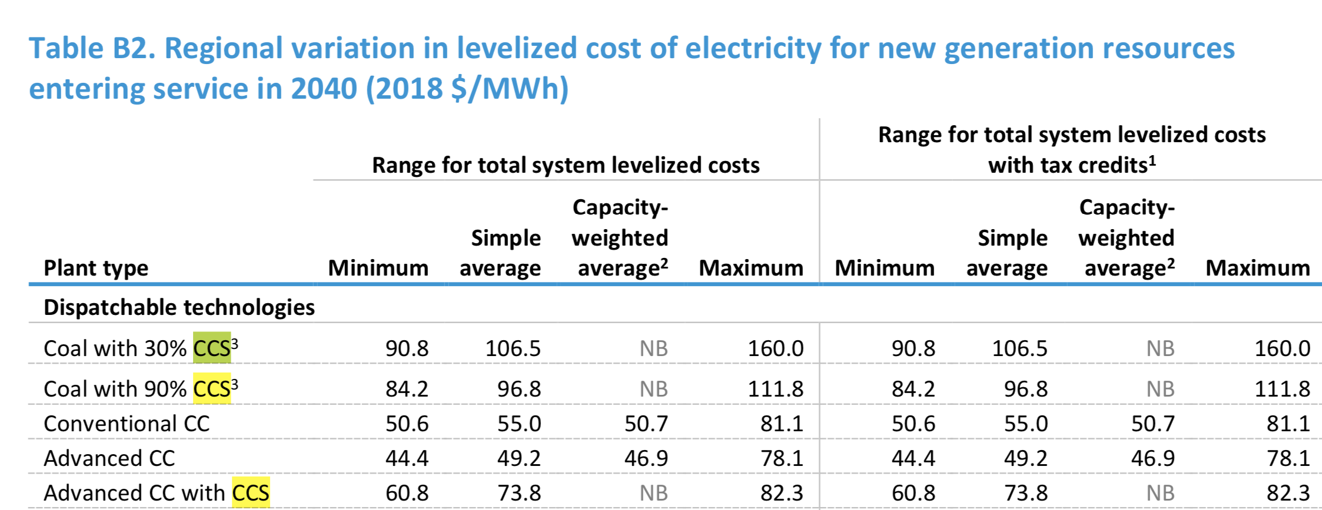

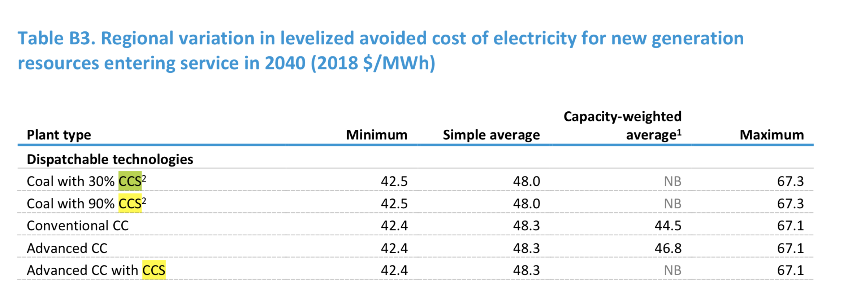

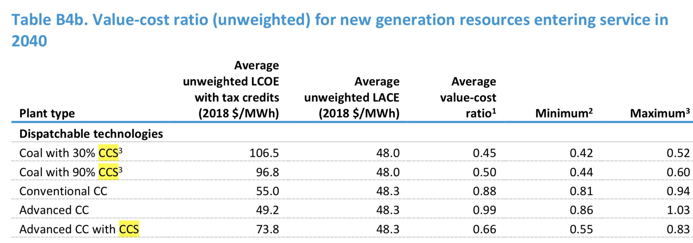

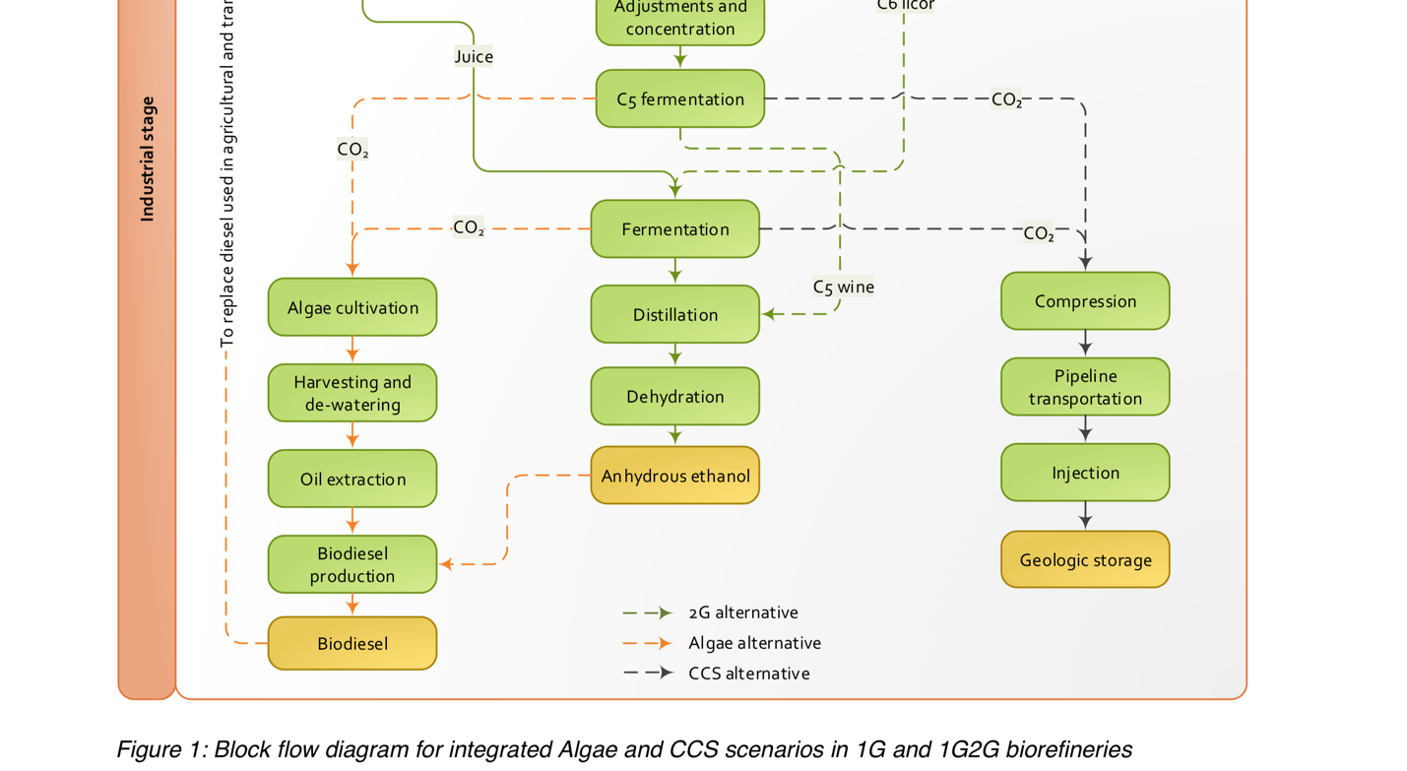3

The CCS technology involves four main steps: conditioning processes to separate CO2 into a pure stream, carbon capture itself, its compression and, finally, storage for long term periods [1]. In the case of CCS applied to power units, significant losses in efficiency are expected; for instance, the Intergovernmental Panel on Climate Change (IPCC) indicates a 9% net reduction in efficiency for coal-fired power plants (pulverized) and 7% for combined cycle gas-fired power plants [1]. 4

The production of ethanol (via the fermentation of sugars) releases a pure stream of CO2, which means there is no penalty for its separation in the CCS proces

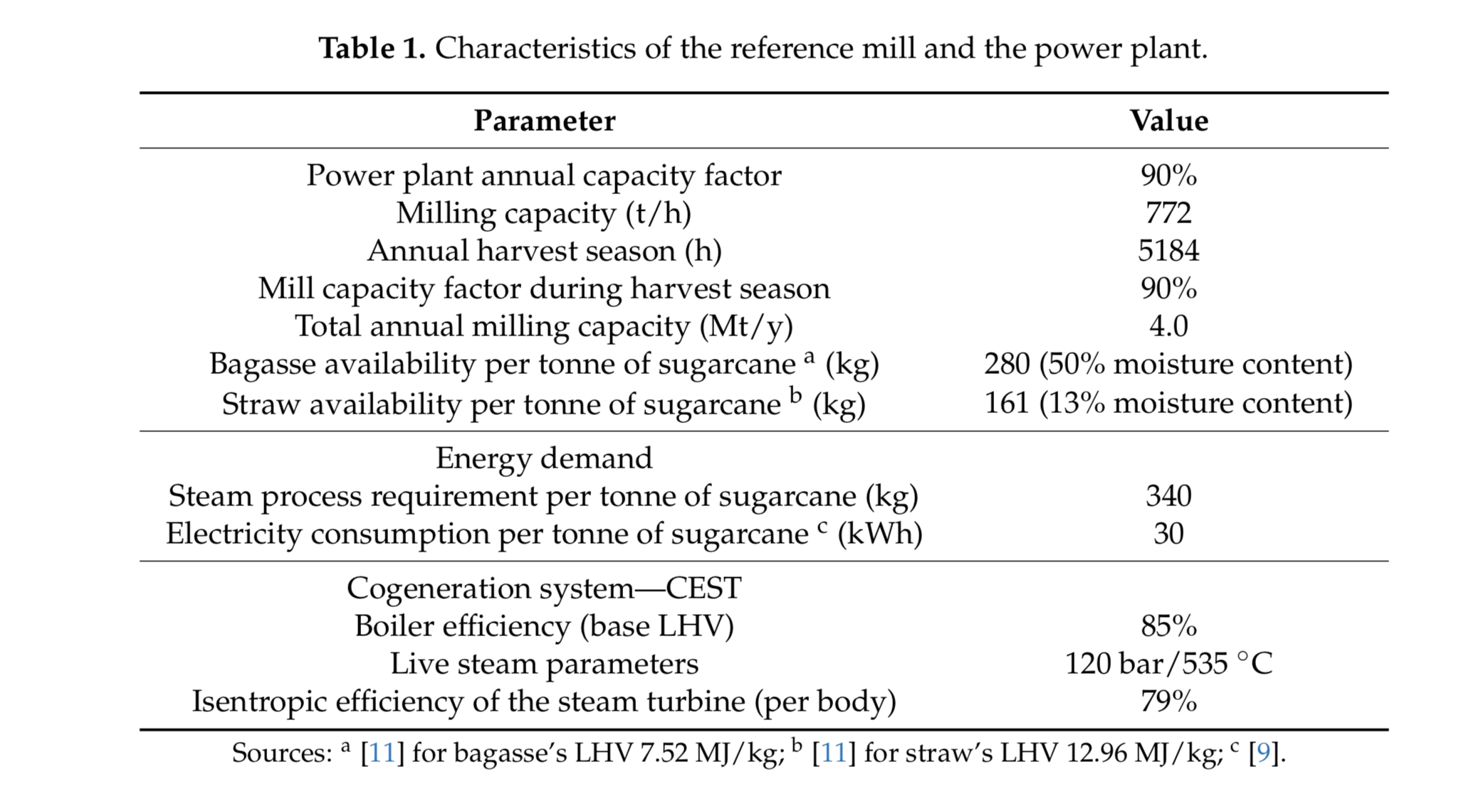

*2.2. CCS Unit*

Carbon dioxide both from fermentation and from biomass combustion were considered to be processed in a CCS unit. CO2 from the combustion passes through the complete CCS process (referred to as absorption, regeneration and compression), while CO2 from fermentation only passes through the compression steps. These two streams are combined in the transportation and storage stages. It was assumed a post-combustion technology based on capture with monoethanolamine (MEA).

2.2.1. MEA Technology

Capture process by absorption is the reference technology and MEA is the incumbent solvent used. Absorption characteristics of the solvent determine energy penalties and impact the economic feasibility

of capturing. In this study, parameters of the capture process based on MEA technology were taken from [7]. Solvent regeneration was considered using steam extracted at the medium-pressure stage of the steam turbine, that coincidentally is the same pressure required by the industrial process (i.e., 2.5 bar, 137 ◦C). The three levels of heat requirement for solvent regeneration are related with the different stages of technology development: 4.4 GJ/t CO2 (1998 kg of steam per tonne of CO2); 2.6 GJ/t CO2 (1180 kg of steam per tonne of CO2); and 1.6 GJ/t CO2 (726 kg of steam per tonne of CO2). It was assumed 90% as the maximum possible capture rate in the CCS unit. Absorption and regeneration take place in the unit hereafter referred to as CCS. Power requirement for flow gases treatment (at the CCS unit) was estimated at 25.84 kW per unit of exhaust gas flow, in kg/s [18]. This figure includes electricity requirement for pumps and blowers, capture pre-treatment pumping, cooling water pumping and blower duties and, finally, solvent pumping duties.

2.2.2. Compression Unit

After CO2 separation from the exhaust gases, it goes to the compression unit, being its power requirement estimated from [19]. CO2 is compressed from 1 bar to 150 bar in order to be transported through a pipeline. Compression is divided into two steps: first compression from 1 bar to the CO2 critical pressure (73.9 bar), and then, in the liquid phase, a pump can be used to boost final pressure. First step was assumed as an ideal gas compression in 5-stages with intermediate cooling, and 85% isentropic efficiency per stage. Pumping requirement was calculated with isentropic efficiency of 85%. Power requirements were considered for each CO2 stream.

**How is CO2 stored underground?**

https://www.iea.org/topics/carbon-capture-and-storage/storage/

CO2 storage involves the injection of captured CO2 from various sources into deep underground geological reservoirs of porous rock (the reservoir) overlain by a layer an impermeable layer of rocks (seal), which prevent the upward migration of CO2 beyond the storage complex. There are several types of geological formations which are suitable for CO2 storage mainly saline aquifers and depleted oil and gas reservoirs. Depleted oil and gas reservoirs are porous rock formations containing either mainly crude oil or gas that has been physically held in stratigraphic or structural traps for millions of years. Saline aquifers are layers of porous and permeable rocks saturated with salty water (brine), which are fairly widespread in both onshore and offshore sedimentary basins.

Projects such as the Sleipner CCS project in Norway have been demonstrating safe and secure storage of CO2 for more than 20 years. There are now four projects undertaking dedicated geological storage at large-scale and one in construction.

Global CO2 storage resources are considered to be well in excess of likely future requirements, even under very ambitious scenarios. However, in many regions significant further assessment work is required to convert theoretical storage capacity into “bankable” storage.

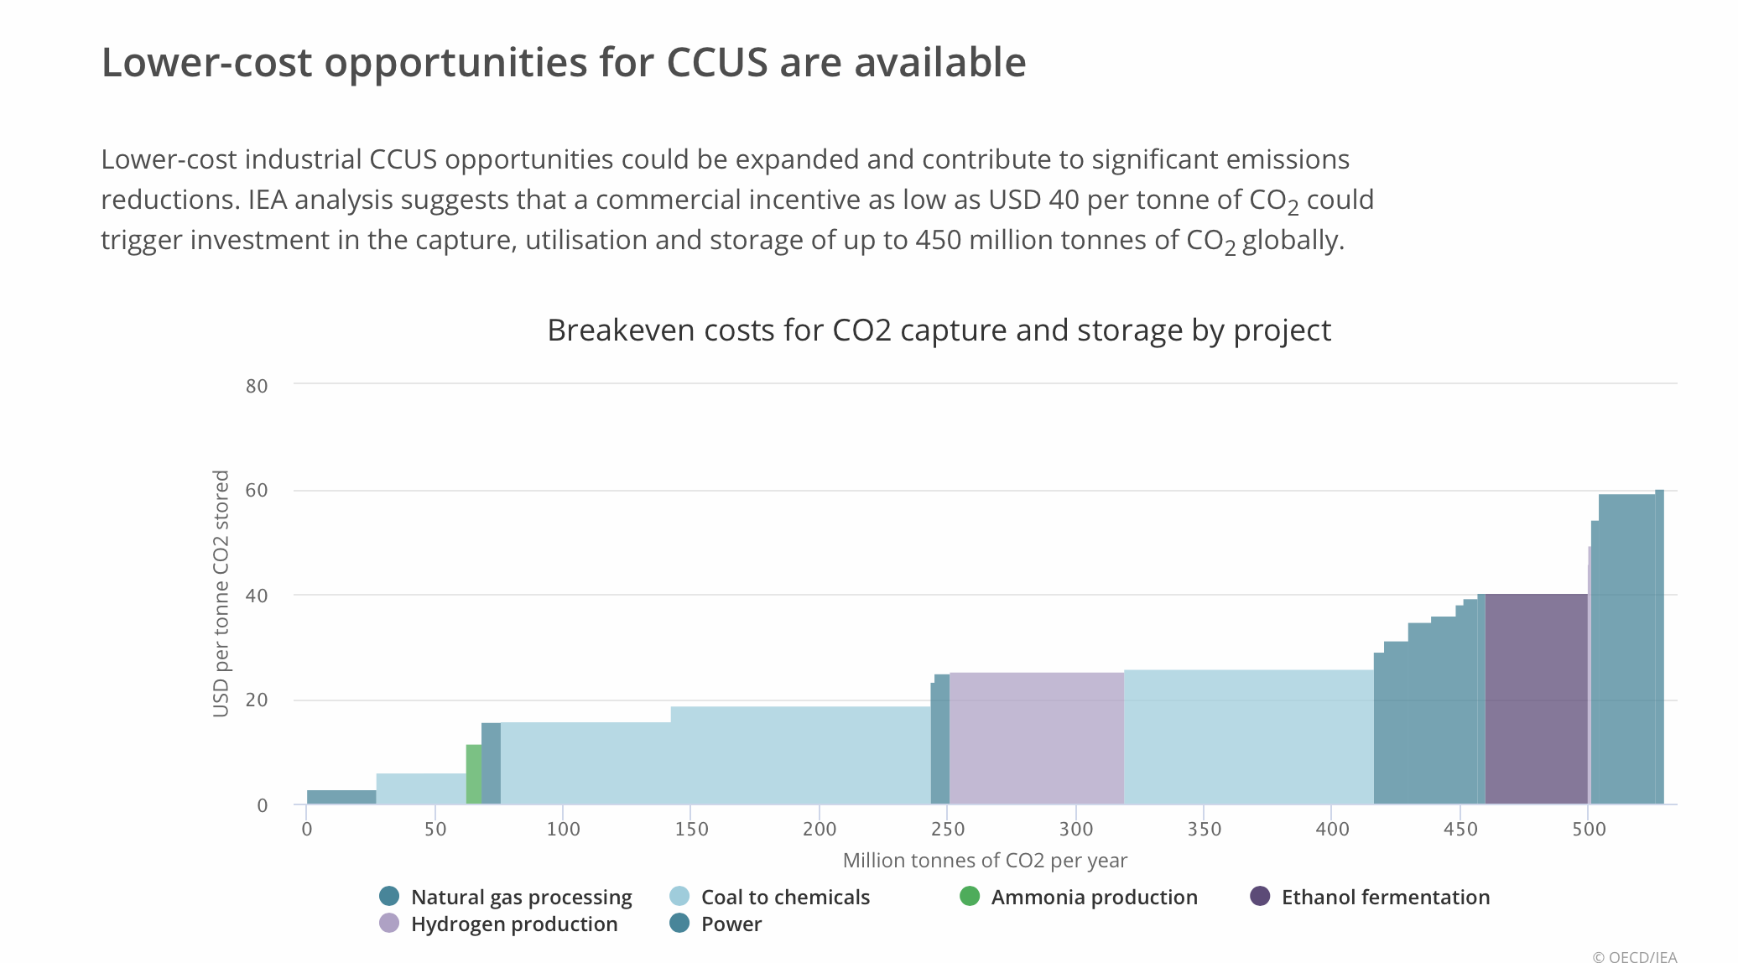

Many countries are supporting CCUS development and deployment around the word. This includes  the Unites States, which in 2018 introduced a significant stimulus for CCUS investment with the passage of legislation to expand and enhance the so-called 45Q tax credit. This will provide up to USD 50 per tonne of CO2 permanently stored and USD 35 per tonne of CO2 used for enhanced oil recovery (EOR) or other industrial uses of CO2, provided emissions reductions can be clearly demonstrated. The [IEA estimates](https://www.iea.org/newsroom/news/2018/march/commentary-us-budget-bill-may-help-carbon-capture-get-back-on-track.html) that this could trigger new capital investment on the order of USD 1 billion over the next six years, potentially adding 10 to 30 million tonnes or more of additional CO2 capture capacity.

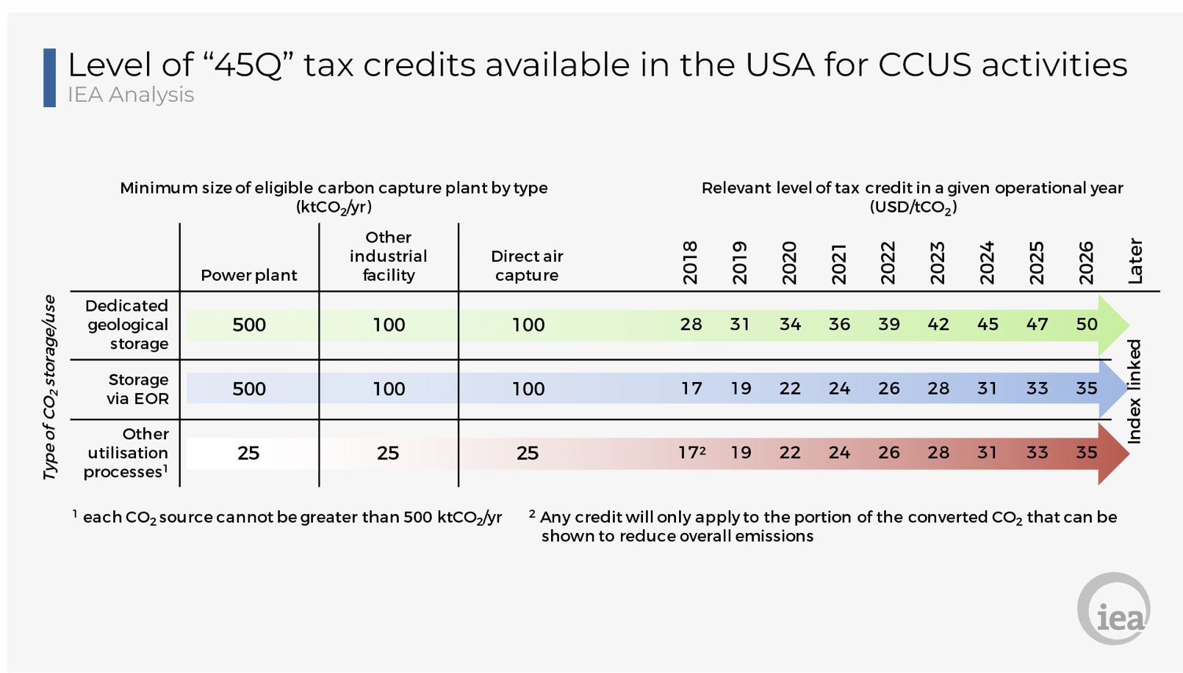

 CCUS project linked with bioenergy came online at the Illinois Industrial CCUS Project producing corn ethanol.

In the [Sustainable Development Scenario](https://www.iea.org/weo/weomodel/sds) (SDS), CCUS contributes 10.6 Gt CO2 of emissions reductions in the industry sector through 2040. The SDS targets 1 340 Mtpa by 2040, including 1 160 Mtpa in industrial applications and 180 Mtpa in fuel transformation.

CO2 capture involves the separation of CO2 from industrial processes and energy-related point sources such as power plants. Separating the CO2 requires energy and often involves modifications to existing processes by adding extra process steps. After separation, the CO2 stream can be further purified and compressed to make it ready for transport. CO2 capture is typically divided into four main categories. In certain cases, these categories can be combined to create hybrid routes to capture.

The cost of capture varies greatly per point source, ranging from around 20 USD per tonne of CO2 for high-purity sources (e.g. natural gas processing) to well over 100 USD per tonne of CO2 for small dilute point sources (e.g. small industrial boilers).